EV Charger
Product Catalogue
Keep Forging Ahead with Boundless Energy

EV CHARGER PRODUCT CATALOGUE

P04

EXP30K2
30kW DC Charging Power with Two DC Charging Connectors
+ Optional 22kW AC Type 2 Charging Socket

P10
EXP480K6
480kW DC Charging Power with Two DC Charging Connectors
P06

EXP60K3
60kW DC Charging Power with Two DC Charging Connectors
+ Optional 22kW AC Type 2 Charging Cable

P12
EXP300H9
180kW/240kW DC Charging Power with Two DC Charging Connectors + Optional 22kW AC Type 2 Charging Socket
P08

EXP180K2, EXP240K5
180kW/240kW DC Charging Power with Two DC Charging Connectors + Optional 22kW AC Type 2 Charging Socket

P14
EXP600K3
600kW Power Cube/12 Charging Connectors/Overhead Charging Dispenser Solution

P22
P16
EXP800K6
800kW Power Cube/12 Charging Connectors/MCS Dispenser/ Overhead Charging Dispenser Solution
P18
IHEBS470K7D-350LL3C
400kW Charging Power/6 Charging Connectors/350kWh Split Type Battery Buffer Charger
P20
G3 Charging Dispenser
200A/250A/300A/375A/380A/
500A/600A Charging Connector
MCS Charging Dispenser
200A/250A/300A/375A/380A
/500A/600A/1500A Charging Connector
P24

IHEBV470K7D-350LL3C
P26
V2G Charging Solution
22kW/44kW/66kW/132kW V2G DC Fast Charger
400kW Charging Power/2 Charging Connectors/350kWh All-in-One Battery Buffer Charger

POS machine
can be installed

Introduction

EXP30K2 DC charger is specifically designed for wall-mount, pedestal and movable installations, and is fully compatible with CCS/NACS/CHAdeMO/GBT EV charging standards. It features a small size and light weight, making it easy to install and relocate, along with a user-friendly interface, IP54 protection, and a robust, durable design for various outdoor applications. It can deliver up to 30kW charging power and 150Vdc to 1000Vdc charging voltage. It can be configured with an optional 22kW/32A AC Type 2 charging socket and portable accessories.

Main Features

Flexible installation options: wall-mount/pedestal
installation, portable cart installation

CCS1/CCS2/GBT/CHAdeMO/NACS support, AC Type 2 charging socket support

WEB/APP Maintenance Backend System enhances  the operation and maintenance effectiveness
TUV CE, cTUVus, RED, CB, OCA, FCC, CTEP and
Energy Star certification

Optional cable retractor/credit card payment
(POS), VIN code support BABA support

Operating temperature -30°C~+65°C, full power output below 45°C, power derating 5%/°C above 45°C

Transportation/Storage
temperature -40°C~+75°C

Relative humidity ≤95%RH, non-condensing

Altitude 2000m

Atmospheric pressure 80kPa~110kPa

Cooling method Air cooling

Protection rating IP54/IK10 (IK08 for touch screen)

Input Parameters
AC frequency 45Hz~65Hz

AC voltage CE: 3-phase+N+PE, 380/400Vac±10%; UL: 3-phase+PE, 480Vac±10%

Max input current CE: 48A+32A (for AC output); UL: 38A

Power factor >0.99

THDi <3% (rated input)

Output Parameters
Max DC output power 30kW

DC output voltage 150Vdc~1000Vdc Constant power voltage range 300Vdc~1000Vdc Max DC output current 100A
Optional AC charging output AC charging socket 32A/3P/22kW

Performance
Max system efficiency >95% (rated input and output)

Standby power CE: 48W; UL: 42W

Noise ≤80dB

Standard
Backend OCPP 1.6J, support firmware update to 2.0x, OTA/PnC/smart charging/power management support

CCS PLC communication DIN70121 and ISOI5118

CHAdeMO CHAdeMO V1.2

GBT GB/T 18487.1-2015, GB/T 27930-2015, GB/T 20234.1~3-2015 TUV CE, cTUVus, RED, CB, OCA, FCC, CTEP, Energy Star

Certification

UL 2202/CSA C22.2; EN IEC 61851-21-2 Class B; EN IEC 61851-1/EN IEC 61851-23/EN 61851-24

Manufacture BABA support

Function and Interface
HMI Tempered glass protective 7" TFT touch screen LCD, 3 * RGB LED, EPO

Metering DC energy meter, DL/T645 standard, optional MID-certified meter

Monitoring interface LAN and LTE wireless modem support

Charging mode Auto/By Time/By Plan/By kWh/By SOC

Power switching mode Two DC charging connectors charging in sequence, AC socket/cable charging in parallel Payment RFID, Mobile APP, POS (optional)
MBE function support WEB/APP Maintenance Backend System enhances the operation and maintenance effectiveness

Charging Protection
Overcurrent protection, short circuit protection, overvoltage protection, undervoltage protection

Insulation monitoring, protective earth connection monitoring Reverse polarity protection, overtemperature protection RCDB for AC charging socket/cable protection

Configuration
Charging module REG1K0100G/U 30kW 1000V power module

Charging connector One or two CCS/NACS/GBT connectors, CHAdeMO + CCS/NACS/GBT connectors, optional AC Type 2 charging socket

Charging connector capacity GBT: 125A; CCS: 125A; NACS: 125A; CHAdeMO: 125A; AC: 32A/22kW

Optional pedestal Pedestal with two cable retractors and a light bar Optional portable accessary Wheeled cart

Mechanical Parameters
Dimensions (W*D*H) 610mm*270mm*610mm Weight (cabinet+module+AC box) 62.5kg+22.5kg+10kg=95kg

*The product is continuously evolving. Please refer to the latest datasheet for specifications.

Introduction
EXP60K3 DC charger is specifically designed for wall-mount and pedestal installations, and is fully compatible with CCS/NACS/ CHAdeMO/GBT EV charging standards. It features a small size and light weight, making it easy to install and relocate, along with a user-friendly interface, IP55 protection, and a robust, durable design for various outdoor applications. It can deliver up to 60kW
charging power and 150Vdc to 1000Vdc charging voltage. It can be configured with optional 22kW/32A AC Type 2 charging cables.

Main Features

Flexible installation options: wall-mount/pedestal
installation
CCS1/CCS2/GBT/CHAdeMO/NACS support, AC Type 2 charging cable support

WEB/APP Maintenance Backend System enhances the operation and maintenance effectiveness
TUV CE, cTUVus, RED, CB, OCA, FCC, CTEP and
Energy Star certification
Optional cable retractor/credit card payment
(POS), VIN code support

Three vehicles charging at the same time

IP55 protection, reliable & robust High power density with best space efficiency
BABA support

Operating temperature -30°C~+70°C, full power output up to 50°C, power derating 5%/°C above 50°C

Transportation/Storage
temperature -40°C~+75°C

Relative humidity ≤95%RH, non-condensing

Altitude 2000m

Atmospheric pressure 80kPa~110kPa

Cooling method Air cooling

Protection rating IP55/IK10 (IK08 for touch screen)

Input Parameters
AC frequency 45Hz~65Hz

AC voltage CE: 3-phase+N+PE, 380/400Vac±10%; UL: 3-phase+PE, 480Vac±10%

Max input current CE: 97A+32A (for AC output); UL: 77A

Power factor >0.99

THDi <3% (rated input)

Output Parameters
Max DC output power 60kW

DC output voltage 150Vdc~1000Vdc Constant power voltage range 300Vdc~1000Vdc Max DC output current 200A
Optional AC charging output AC charging cable 32A/3P/22kW

Performance
Max system efficiency >95% (rated input and output)

Standby power CE: 44W; UL: 53.2W

Noise ≤72dB

Standard
Backend OCPP 1.6J, support firmware update to 2.0x, OTA/PnC/smart charging/power management support

CCS PLC communication DIN70121 and ISOI5118

CHAdeMO CHAdeMO V1.2

GBT GB/T 18487.1-2015, GB/T 27930-2015, GB/T 20234.1~3-2015 TUV CE, cTUVus, RED, CB, OCA, FCC, CTEP, Energy Star

Certification

UL 2202/CSA C22.2; EN IEC61851-21-2 Class B; EN IEC61851-1/EN IEC61851-23/EN 61851-24

Manufacture BABA support

Function and Interface
HMI Tempered glass protective 7" TFT touch screen LCD, RGB LED, EPO

Metering DC energy meter, DL/T645 standard, optional MID-certified meter

Monitoring interface LAN and LTE wireless modem support

Charging mode Auto/By Time/By Plan/By kWh/By SOC

Power switching mode Two DC charging connectors charging in sequence, AC Type 2 cable charging in parallel Payment RFID, Mobile APP, POS (optional)
MBE function support WEB/APP Maintenance Backend System enhances the operation and maintenance effectiveness

Charging Protection
Overcurrent protection, short circuit protection, overvoltage protection, undervoltage protection

Insulation monitoring, protective earth connection monitoring Reverse polarity protection, overtemperature protection RCDB for AC charging cable protection

Configuration
Charging module 2 * REG1K0100G2 30kW 1000V power module

Charging connector One or two CCS/NACS/GBT connectors, CHAdeMO + CCS/NACS/GBT connectors, optional AC Type 2 charging cable

Charging connector capacity GBT: 200A; CCS: 200A; NACS: 200A; CHAdeMO: 125A; AC: 32A/22kW

Optional pedestal Pedestal with two cable retractors and a light bar

Mechanical Parameters
Dimensions (W*D*H) 705mm*240mm*1100mm Weight (cabinet+module) 92kg+2*15.5kg=123kg

*The product is continuously evolving. Please refer to the latest datasheet for specifications.

EXP180K2-FD (T)/EXP240K5-FD Fast DC Charger
180kW/240kW DC Charging Power with Two DC Charging Connectors + Optional 22kW AC Type 2 Charging Socket

Introduction
EXP180K2-FD (T)/EXP240K5-FD DC charger adopts all-in-one design and is fully compatible with CCS2/NACS/CHAdeMO/ GBT EV charging standards. It features a small size and light weight, making it easy to install and relocate, along with a user- friendly interface, IP55 protection, and a robust, durable structure suitable for various outdoor applications. It can deliver up to 180kW/240kW charging power and 150Vdc to 1000Vdc charging voltage. It can be configured with an optional 22kW/32A AC Type 2 charging socket and Eichrecht certification.
Main Features

TUV CE, cTUVus, RED, CB, OCA, FCC, CTEP,
Energy Star and NMI Eichrecht1 certification

CCS1/CCS2/GBT/CHAdeMO/NACS support, AC Type 2 charging socket support1
Intelligent power switching matrix dynamically allocates power modules among connectors
WEB/APP Maintenance Backend System enhances the operation and maintenance effectiveness

Optional cable retractor, credit card payment
(POS), VIN code support

Ring network power sharing between two chargers1

IP55 protection, reliable & robust Three vehicles charging at the same time1

Note 1: This feature is supported only by EXP180K2; it is not available on EXP240K5.

Ring Network with Two 180kW Chargers

Each Charging Connector Can Get Full 360kW Power with Ring Network

Charger A-DC1 | ChargerA-DC2 | Charger B-DC1 | Charger B-DC2
90kW | 90kW | 90kW | 90kW
180kW | 0 | 180kW | 0
180kW | 90kW | 90kW | 0
180kW | 180kW | 0 | 0
360kW | 0 | 0 | 0

Input Parameters | AC input current | 291A | 291A+32A | 388A
 | Power factor | >0.99
 | THDi | <3% (rated input)
 | DC output voltage | 150Vdc~1000Vdc
 | Constant power voltage range | 300Vdc~1000Vdc

Output Parameters

Performance

Standard
Max DC output current 600A@300V/360A@500V/180A@1000V 600A@400V/480A@500V/240A
@1000V
Model
EXP180K2-FD
EXP180K2-FT
EXP240K5-FD
Operating temperature -30°C~+70°C, full power output up to 50°C, power derating 5%/°C above 50°C
Transportation/Storage
temperature -40°C~+75°C
Operating Environment Relative humidity ≤95%RH, non-condensing
Altitude 2000m
Atmospheric pressure 80kPa~110kPa
Cooling method Air cooling
AC frequency 45Hz~65Hz
AC voltage CE: 3-phase+(N)+PE, 380/400Vac±10%; UL: 480Vac±10%
Max DC output power 180kW 180kW+22kW 240kW
AC output AC Type 2
32A/22kW/3P
Max system efficiency >95% (rated input and output) >95.5% (rated input and output)
Standby power 40W
Noise <65dB
Backend OCPP 1.6J, support firmware update to 2.0x, OTA/PnC/smart charging/power management support
CCS PLC communication DIN70121 and ISOI5118 CHAdeMO CHAdeMO V1.2
GBT GB/T 18487.1-2015, GB/T 27930-2015, GB/T 20234.1~3-2015
TUV CE, cTUVus, RED, CB, OCA, FCC, CTEP, Energy Star, NMI Eichrecht (for

Certification
EXP180K2-FD)
UL 2202, EN 61851-21-2 Class A; EN 61851-1/EN 61851-23/EN 61851-24

Protection rating IP55/IK10 (IK08 for touch screen)
HMI Tempered glass protective 7" TFT touch screen LCD, 3 * RGB LED, EPO
Metering DC energy meter, GB/T 29318 and JJG1149 standard, optional MID-certified/NMI- certified meter
Monitoring interface LAN and LTE wireless modem support

Function and Interface
Optional ring network power
transfer
Enables power transfer between two chargers, each charging connector can get the
total charging power

Power switching mode Intelligent power switching matrix dynamically allocates power modules among
charging connectors, maximizing overall power utilization efficiency
Payment RFID, Mobile APP, POS (optional)
MBE function support WEB/APP Maintenance Backend System enhances the operation and maintenance effectiveness
Overcurrent protection, short circuit protection, overvoltage protection, undervoltage protection
Insulation monitoring, protective earth connection monitoring
Charging Protection
Reverse polarity protection, overtemperature protection
RCDA main protection and RCDB protection for AC connector
Charging module 6 * REG1K0100G/U 30kW 1000V 6 * REG1K0110U 40kW 1000V
Charging connector 2 * CCS/NACS/GBT or CCS/NACS+GBT/CHAdeMO, optional AC Type 2 charging socket

Configuration
Charging connector capacity GBT: 250A/400A; CCS1: 200A/300A; CCS2: 200A/250A/300A/375A;
NACS: 200A/300A; CHAdeMO: 125A/200A; AC: 32A/22kW
Option 1: Two top-mounted cable retractors + light bar
Optional cable management
Option 2: Two top-mounted folding-arm cable retractors + light bar
Dimensions (W*D*H) 700mm*750mm*1750mm

Mechanical Parameters
Weight (cabinet+module) 320kg+6*22.5kg=455kg 320kg+6*23.5kg=461kg
*The product is continuously evolving. Please refer to the latest datasheet for specifications.

EXP480K6-FD Fast DC Charger

480kW DC Charging Power with Two DC Charging Connectors

Introduction

EXP480K6-FD fast DC charger is specifically designed with high power, high current, high protection and high reliability, and is fully compatible with CCS1/CCS2/NACS/GBT EV charging standards. Featuring all-in-one design and IP55 protection, it is
suitable for diverse harsh environments. It delivers up to 480kW of charging power, with a maximum output current of 600A and a maximum voltage of 1000Vdc. The completely updated design features light bars, 32" (optional 10'') LCD and a more user- friendly connector management system.

Main Features

CCS1/CCS2/NACS/GBT support, optional two
600A liquid-cooled charging connectors

TUV CE, cTUVus, RED, CB, OCA, FCC, CTEP, UKCA,
Energy Star and NMI Eichrecht certification

WEB/APP Maintenance Backend System enhances the operation and maintenance effectiveness

User-friendly interface with a 32" (optional 10'')  tempered glass TFT capacitive touch screen LCD
and 2 RGB LED bars
IP55, IK10, -30°C~+50°C operating temperature full power charging

OCPP 1.6J, support firmware update to 2.0x, PnC, smart charging and power management support

Intelligent power switching matrix dynamically allocates power modules among connectors

Supports LAN and LTE wireless connectivity, OTA
updates, RFID authorization, POS and Mobile APP payments

Operating Environment
Operating temperature -30°C~+70°C, full power output up to 50°C, power derating 5%/°C above 50°C

Transportation/Storage
temperature -40°C~+75°C

Relative humidity ≤95%RH, non-condensing

Altitude 2000m

Atmospheric pressure 79kPa~106kPa

Cooling method Forced air cooling

Protection rating NEMA 3R/IP55/IK10

AC Input
Frequency 45Hz~65Hz

Voltage CE: 3-phase+N+PE, 380/400V±10%; UL: 3-phase+(N)+PE , 480V±10%

Max input current CE: 776A; UL: 614A

Power factor >0.99

THDi <3% (rated input)

DC Output
Voltage 150Vdc~1000Vdc

Constant power voltage range 300Vdc~1000Vdc

Max output current 1200A@400V/960A@500V/480A@1000V

Max output power 480kW

Performance
Max system efficiency ≥96.5%

Standby power 100W

Noise ≤65dB

Standard
Backend OCPP 1.6J, support firmware update to 2.0x, OTA updates, PnC/smart charging/power management
support

CCS PLC communication DIN70121 and ISOI5118

GBT GB/T 18487.1-2015, GB/T 27930-2015, GB/T 20234.1~3-2015

TUV CE, cTUVus, RED, CB, OCA, FCC, CTEP, UKCA, Energy Star, NMI Eichrecht

Certification

Function and Interface

UL 2231, UL 991, UL 2202, CSA C22.2 No.346:22, EN 61000-6-3/EN 61000-6-1 Class A, EN 61851-1/EN 61851-23/EN 61851-24

HMI 32" (optional 10'') tempered glass TFT touch screen LCD, two light bars, EPO

Metering DC energy meter, optional MID-certified and NMI-certified meter

Monitoring interface LAN and LTE wireless modem support

VPF function Optional VPF configuration, from 40kW to 480kW with VPF power module

Power switching mode Intelligent power switching matrix dynamically allocates power modules among charging connectors (with 120kW power step), maximizing overall power utilization efficiency

Payment RFID, Mobile APP, POS (optional)

MBE function support WEB/APP Maintenance Backend System enhances the operation and maintenance effectiveness

Charging Protection
Overcurrent protection, short circuit protection, overvoltage protection, undervoltage protection

Insulation monitoring, protective earth connection monitoring Reverse polarity protection, overtemperature protection

Configuration
Charging module 12 * REG1K0135P2 module for VPF function (optional REG1K0135G2 module) Charging connector configuration 2 * CCS2/CCS1/NACS/GBT
Charging connector capacity GBT: 600A/400A, CCS1: 600A/350A, CCS2: 500A/375A, NACS: 600A/360A

Cable management Two top-mounted cable rocker arms

Mechanical Parameters
Dimensions (W*D*H) 870mm*750mm*2256mm Weight (cabinet+module) 546kg+12*17kg=750kg

*The product is continuously evolving. Please refer to the latest datasheet for specifications.

EXP300H9-FS MCS Charger

300kW DC Charging Power with One MCS Charging Connector

Introduction

EXP300H9-FS Megawatt Charging System (MCS) charger adopts all-in-one design and is compatible with MCS EV charging standard. It features a small size and light weight, making it easy to install and relocate, along with a user-friendly interface, IP55 protection, and a robust, durable structure suitable for various outdoor applications. It can deliver up to 300kW charging power and 250Vdc to 1500Vdc charging voltage.

Main Features

WEB/APP Maintenance Backend System enhances
the operation and maintenance effectiveness Credit card payment (POS), VIN code support

Supports MCS charging with voltage up to 1500V IP55 protection, reliable & robust

Operating temperature -30°C~+70°C, full power output up to 50°C, power derating 5%/°C above 50°C
Transportation/Storage
temperature -40°C~+75°C
Relative humidity ≤95%RH, non-condensing Operating Environment Altitude 2000m
Atmospheric pressure 80kPa~110kPa
Cooling method Air cooling
Protection rating IP55/IK10 (IK08 for touch screen)
AC frequency 45Hz~65Hz
AC voltage CE: 3-phase+(N)+PE, 380/400Vac±10%; UL: 480Vac±10%

Input Parameters
AC input current CE: 485A; UL: 384A
Power factor >0.99
THDi <3% (rated input)
DC output voltage 250Vdc~1500Vdc Constant power voltage range 400Vdc~1500Vdc

Output Parameters
Max DC output current 350A@857V, 300A@1000V, 200A@1500V
Max DC output power 300kW
Max system efficiency >95% (rated input and output)

Performance

Standard
Standby power 40W
Noise <65dB
Backend OCPP 1.6J, support firmware update to 2.0x, OTA/PnC/smart charging/power management support
MCS PLC communication DIN70121, ISOI5118
HMI Tempered glass protective 7" TFT touch screen LCD, RGB LED, EPO
Metering DC energy meter
Monitoring interface LAN and LTE wireless modem support

Function and Interface
Payment RFID, Mobile APP, POS (optional)
MBE function support WEB/APP Maintenance Backend System enhances the operation and maintenance effectiveness
Overcurrent protection, short circuit protection, overvoltage protection, undervoltage protection
Insulation monitoring, protective earth connection monitoring
Charging Protection
Reverse polarity protection, overtemperature protection
RCDA main protection (CE version only)
Charging module 6 * REG1K5125G2 50kW 1500V

Configuration
Charging connector 1 * MCS
Charging connector capacity MCS: 350A
Dimensions (W*D*H) 700mm*750mm*1750mm

Mechanical Parameters
Weight (cabinet+module) 320kg+6*20kg=440kg
*The product is continuously evolving. Please refer to the latest datasheet for specifications.

600kW Power Cube/12 Charging Connectors/Overhead Charging Dispenser Solution

Introduction
EXP600K3-FWR5 split type high power charger is specifically designed for EV charger operators with flexible split and multi charging point solutions. It supports CCS/NACS/CHAdeMO/GBT charging connectors, delivers up to 600kW of output power, and accommodates up to 12 charging connectors via 6 dual-connector dispensers or 12 single-connector dispensers. It also supports 500A liquid-cooled charging connectors, and each connector can receive maximum power through intelligent power switching. An intelligent power switching matrix dynamically allocates power modules among charging connectors, maximizing overall power utilization efficiency. The overhead dispenser solution for bus depots is also available, utilizing the same power cube.
Main Features

Building-block modular design, simplified & standardized interface

Max 12 charging channels, 300A or 500A
configuration

TUV CE, cTUVus, RED, CB, OCA, FCC, CTEP and
Energy Star certification
Power cube IP55, floor-standing dispenser IP55,
overhead dispenser IP65, reliable & robust Patented U-Type air duct design

Customizable dispenser, overhead dispenser solution for bus depots

WEB/APP Maintenance Backend System enhances the operation and maintenance effectiveness

High power density with best space efficiency Power cube 65dB, floor-standing dispenser 55dB,
 overhead dispenser 0dB

BABA support

Power Cube EXP600K3-FWR5
Frequency 45Hz-65Hz
Voltage CE: 3-phase+(N)+PE, 380Vac/400Vac±10%; UL: 3-phase+(N)+PE, 480Vac±10%

AC Input

DC Output

Performance
Max input current CE: 2*480A@380Vac; UL: 2*380A@480Vac Power factor >0.99
THDi <5% (rated input)
Voltage 150Vdc~1000Vdc
Constant power voltage
range 300Vdc~1000Vdc
Max output current 500A (optional 300A) for each output charging channel
Max output power 600kW
Output channel Max 12 output charging channels as the input of the charging dispensers Dispenser support Max 6 dual-connector dispensers or 12 single-connector dispensers System efficiency >95.5% (rated input and output)
Standby power 70W
Noise <65dB
Dimensions (W*D*H) 1050mm*1150mm*2200mm

Mechanical Parameters
Weight (cabinet+module) 690kg+20*15.5kg=1000kg
Power module 20 * REG1K0100G2 (30kW 1000V)
Power switching mode Intelligent power switching matrix dynamically allocates power modules among charging connectors, maximizing overall power utilization efficiency
HMI RGB LED, E-STOP
Others HMI kiosk (optional) Tempered glass protective 10.1" capacitive touch screen LCD, RFID, POS (optional)
Protection rating IP55
Certification TUV CE, cTUVus, RED, CB, OCA, FCC, CTEP, Energy Star
Manufacture BABA support
Floor-Standing Dispenser Overhead Dispenser

Charging Dispenser

DC Input
 | Input channel (DC bus) | 2 |  |  |  | 1
 | Charging cable | 2 |  |  |  | 1
 | Voltage | 150Vdc~1000Vdc
DC Output | Max output current | 2*250A | 2*375A | 500A+250A | 2*500A | 250A | 375A
 | Optional (boost current) | 2*375A | 2*500A | 700A+375A | 2*700A | 375A | 500A
 | Max output power | 2*250kW | 2*375kW | 500kW+250kW | 2*500kW | 250kW | 375kW

EXP250-FDC EXP400-FDC EXP500-LDC EXP500-LLDC EXP250-FSW EXP400-FSW
Voltage 150Vdc~1000Vdc

Dimensions (W*D*H) 500mm*260mm*1800mm 763mm*240mm*415mm
Mechanical Parameters
Weight 185kg 195kg 50kg
HMI Tempered glass protective 7" capacitive touch screen LCD for floor-standing dispenser, RGB panel LED, E-STOP,
RFID, POS (optional)
Metering DC energy meter, GB/T 29318 and JJG1149 standard, optional MID-certified meter
Backend OCPP 1.6J, support update to 2.0, PnC/smart charging/power management support, LAN 100M and LTE wireless modem support
Cable management Top-mounted two cable retractors and a light bar for floor-standing dispenser. Select one or two cable
retractors based on cable length for overhead dispenser
MBE function WEB/APP Maintenance Backend System enhances the operation and maintenance effectiveness
Others
Overcurrent/short circuit/overvoltage/undervoltage/RCD/insulation/overtemperature protection
Charging protection Reverse polarity protection
Charging connector 2*GBT/CCS/NACS or CCS+NACS/GBT/CHAdeMO or 1*GBT/CCS/NACS CCS/GBT/NACS

Charging connector capacity
CCS: 200A/250A/300A/375A/500A; NACS:200A/300A/380A; CHAdeMO: 125A/200A;
GBT: 250A/400A/500A

Protection rating IP55/IK10 IP65
Certification TUV CE, cTUVus, RED, CB, OCA, FCC, CTEP, Energy Star
Noise 0 55dB 0

Operating Environment

Operating temperature
Transportation/Storage
temperature Relative humidity Altitude
Atmospheric pressure
Cabinet cooling
-30°C~+70°C, full power output up to 50°C, power derating 5%/°C above 50°C
-40°C~+75°C
≤95%RH, non-condensing 2000m
80kPa~110kPa Air cooling
Standard

Charging standard
EMC/safety
GBT 27930-2011/27930-2015, CHAdeMO V1.2/V2.0, DIN70121, ISO15118, OCA
EN 61851-21-2, EN 61000-6-4, EN 61000-6-2 Class A, EN 61851-1, EN 61851-23, EN 61851-24, UL 2202, CSA C22.2
*The product is continuously evolving. Please refer to the latest datasheet for specifications.

800kW Power Cube/12 Charging Connectors/MCS Dispenser/Overhead Charging Dispenser Solution

Introduction
EXP800K6-FWR8 split type high power charger is specifically designed for the EV charger operators with split and multi charging point applications. It supports MCS/CCS/NACS/GBT charging connectors, delivers up to 800kW/1.6MW of output power, and accommodates up to 12 charging connectors via 6 dual-connector dispensers or 12 single-connector dispensers.
It also supports 500A/600A/1500A liquid-cooled charging connectors, and each connector can receive maximum power through intelligent power switching. An intelligent power switching matrix dynamically allocates power modules among charging connectors, maximizing overall power utilization efficiency. Two power cubes can be connected in parallel to achieve 1.6MW output, equipped with an MCS charging dispenser.

Main Features

Building-block modular design, simplified & standardized interface

Up to 12 charging channels, configurable for 300A, 500A, or max 800A output

TUV CE, cTUVus, RED, CB, FCC, OCA, and NMI
Eichrecht certification
Power cube IP55, floor-standing dispenser IP55,
overhead dispenser IP65, reliable & robust
High power density with best space efficiency
BABA support
Customizable dispenser, overhead dispenser solution for bus depots

WEB/APP Maintenance Backend System enhances the operation and maintenance effectiveness
Supports two power cubes in parallel for one
dispenser, delivering up to 1.6MW output power
Power cube 65dB, floor-standing dispenser 55dB,
overhead dispenser 0dB
Patented U-Type air duct design

Power Cube EXP800K6-FWR8
Frequency/Voltage 45Hz~65Hz; CE: 3-phase+(N)+PE, 380/400Vac±10%; UL: 3-phase+(N)+PE, 480Vac±10%
Max input current CE: 2*640A@380Vac; UL: 2*506A@480Vac
AC Input
Power factor >0.99
THDi <5% (rated input)
Voltage 150Vdc~1000Vdc (constant power voltage range 300Vdc~1000Vdc) Max output current 800A for each output charging channel

DC Output

Performance
Max output power 800kW
Output channel Max 12 output charging channels as the input of the charging dispensers Dispenser support Max 6 dual-connector dispensers or 12 single-connector dispensers System efficiency 97% (peak efficiency)
Standby power 70W
Noise <65dB
Dimensions (W*D*H) 1050mm*1100mm*2200mm

Mechanical Parameters
Weight (cabinet+module) 800kg+20*17kg=1140kg
Power module 20 * REG1K0135G2 (40kW 1000V)
Power switching mode Intelligent power switching matrix dynamically allocates power modules among charging connectors, maximizing overall power utilization efficiency
HMI RGB LED, E-STOP
Others HMI kiosk (optional) Tempered glass protective 10.1" capacitive touch screen LCD, RFID, POS (optional)
Protection rating IP55
Certification TUV CE, cTUVus, RED, CB, OCA
Manufacture BABA support
Floor-Standing Dispenser
Overhead Dispenser G3 Dispenser MCS Dispenser

Charging Dispenser
EXP250-FFC EXP400-FFC EXP500-LL5C
EXP600-LL6C

EXP800-LC EXP1500-HLL5C/6C EXP250/400-FSW

DC Input Input channel 2 1 2/3 1
Charging cable 2 1 2 1
Voltage 150Vdc~1000Vdc

DC Output
Max output current 2*250A 2*375A 2*500/600A 800A 1500A+500A/600A 250A/375A Optional (boost current) 2*375A 2*500A 2*700A 1000A 1500A+700A 375A/500A Max output power 2*250kW 2*375kW 2*500/600kW 800kW 800kW/1600kW 250kW/375kW
Dimensions (W*D*H) 560*300*2000mm 355*730*2200mm 763*240*415mm

Mechanical Parameters
Weight 230kg 260kg 330kg 50kg
HMI Tempered glass protective 10.1'' (optional 21.5'') capacitive touch screen LCD, RGB panel LED, E-STOP, RFID, QR
code, POS (optional)
Metering DC energy meter, MID-certified meter, optional NMI-certified meter
Backend OCPP 1.6J/2.0.1 (optional 2.3X), PnC/OTA/smart charging/power management support, LTE wireless modem/
Ethernet
Cable management Top-mounted swing-arm for cable retraction
MBE function WEB/APP Maintenance Backend System enhances the operation and maintenance effectiveness Overcurrent/short circuit/overvoltage/undervoltage/RCD/insulation/overtemperature protection
Charging protection
Reverse polarity protection
Others
CCS+MCS/NACS+MCS/

Charging connector 2*CCS/NACS/GBT or CCS+NACS/GBT or 1*CCS/NACS/GBT

Charging connector
GBT+MCS/CCS+CCS, or CCS/GBT/NACS
1*MCS

capacity MCS: 1500A; CCS: 200A/250A/300A/375A/500A/600A; NACS: 200A/300A/380A/600A; GBT: 250A/500A/600A

Protection rating IP55 (NEMA 3S)/IK10 (IK08 for 10.1" LCD, IK09 for 21.5" LCD) IP55 (NEMA 3S)/IK10
(IK08 for 10.1" LCD)

IP65

Certification TUV CE, cTUVus, RED, CB, FCC, OCA, NMI Eichrecht
Noise 0 55dB 0

Operating Environment

Operating temperature  Transportation/Storage  temperature Relative humidity Altitude  Atmospheric pressure | -30°C~+70°C, full power output up to 50°C, power derating 5%/°C above 50°C  -40°C~+75°C  ≤95%RH, non-condensing 3000m  80kPa~110kPa
Cabinet cooling | Air cooling
Standard

Charging standard
EMC/safety
GBT 27930-2011/27930-2015, DIN70121, ISO15118, OCA
EN 61851-21-2, EN 61000-6-4, EN 61000-6-2 Class A, EN 61851-1, EN 61851-23, EN 61851-24, UL 2202, CSA C22.2
*The product is continuously evolving. Please refer to the latest datasheet for specifications.

IHEBS470K7D-350LL3C Liquid-Cooled Split Type Battery Buffer Charger
400kW Charging Power/6 Charging Connectors/350kWh Charger

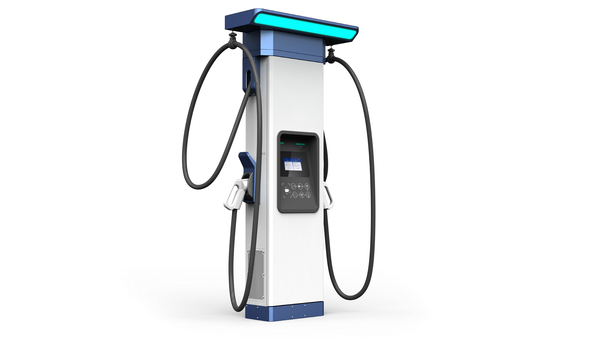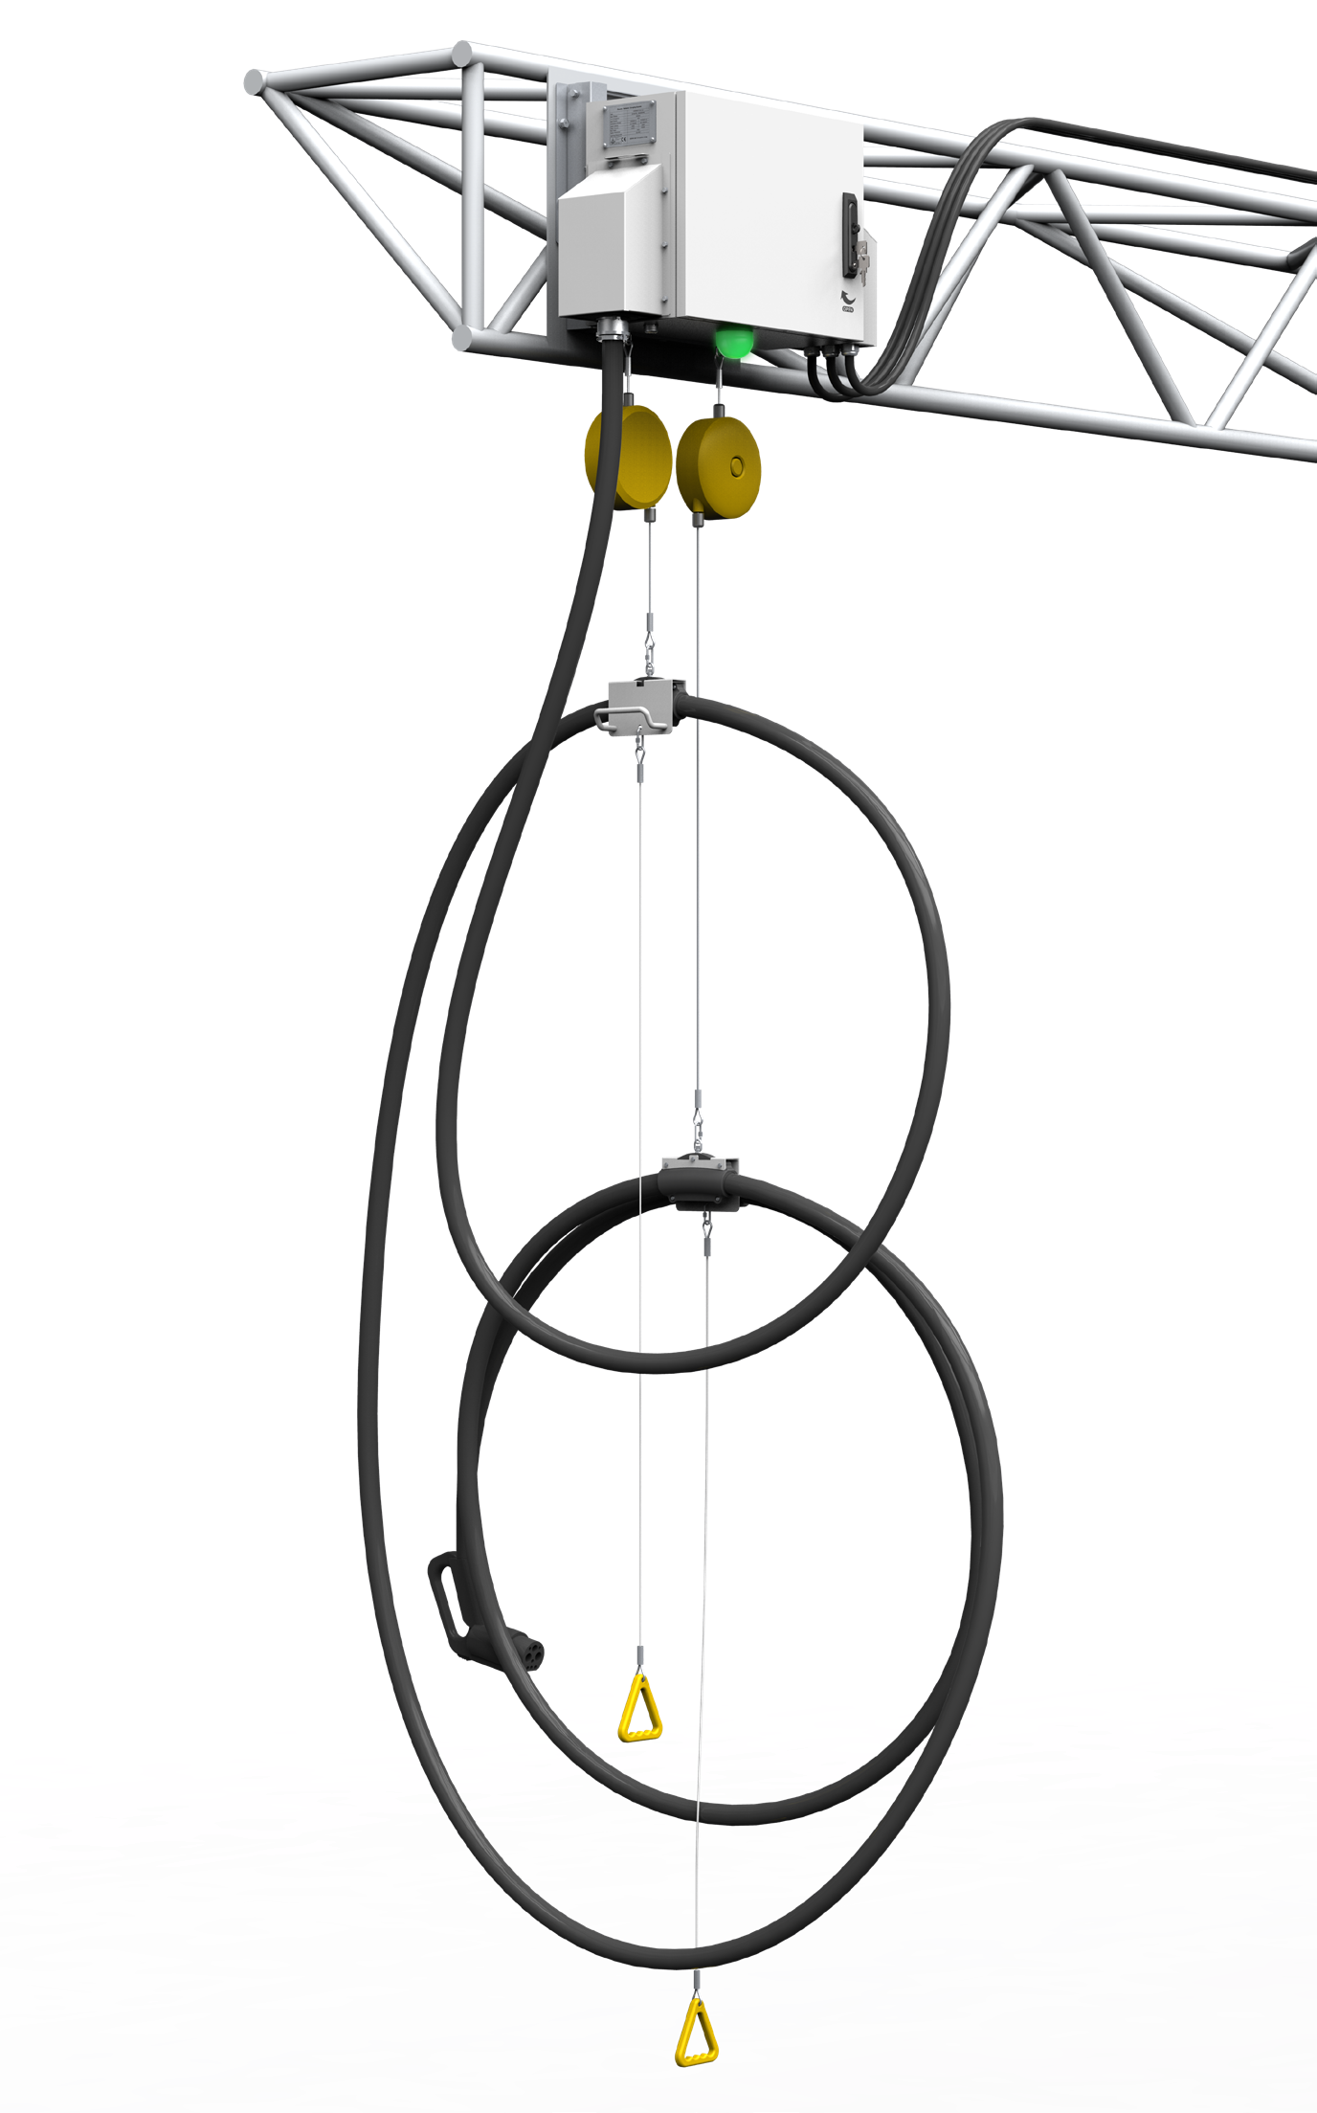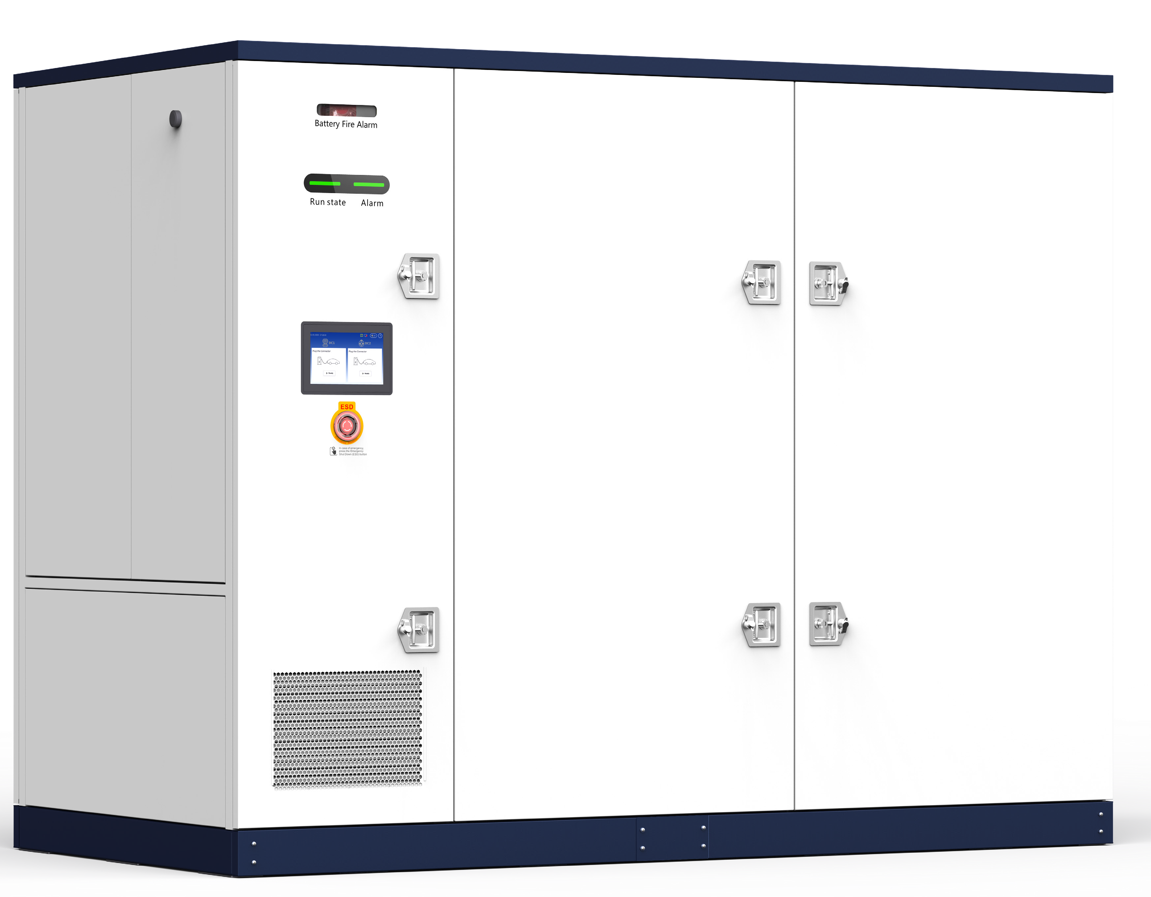
Introduction
IHEBS470K7D-350LL3C Liquid-Cooled Split Type Battery Buffer Charger utilizes LFP battery for energy storage. With the support of local and cloud-based EMS, it helps balance power supply and demand among the grid, battery system, EV charging and renewable energy sources. A fully liquid-cooled solution enables 1P discharge performance, allowing the system to operate under limited AC grid capacity while still delivering high-power charging. This approach achieves high cost efficiency and a compact footprint. The system provides significant value in grid peak shaving, renewable energy integration, and grid capacity expansion by discharging battery power to grid.
Main Features

Fully liquid-cooled design from power modules to battery packs and charging cables
Total electrical isolation between the grid,
battery, EV and PV input
 1P fast charging/discharging
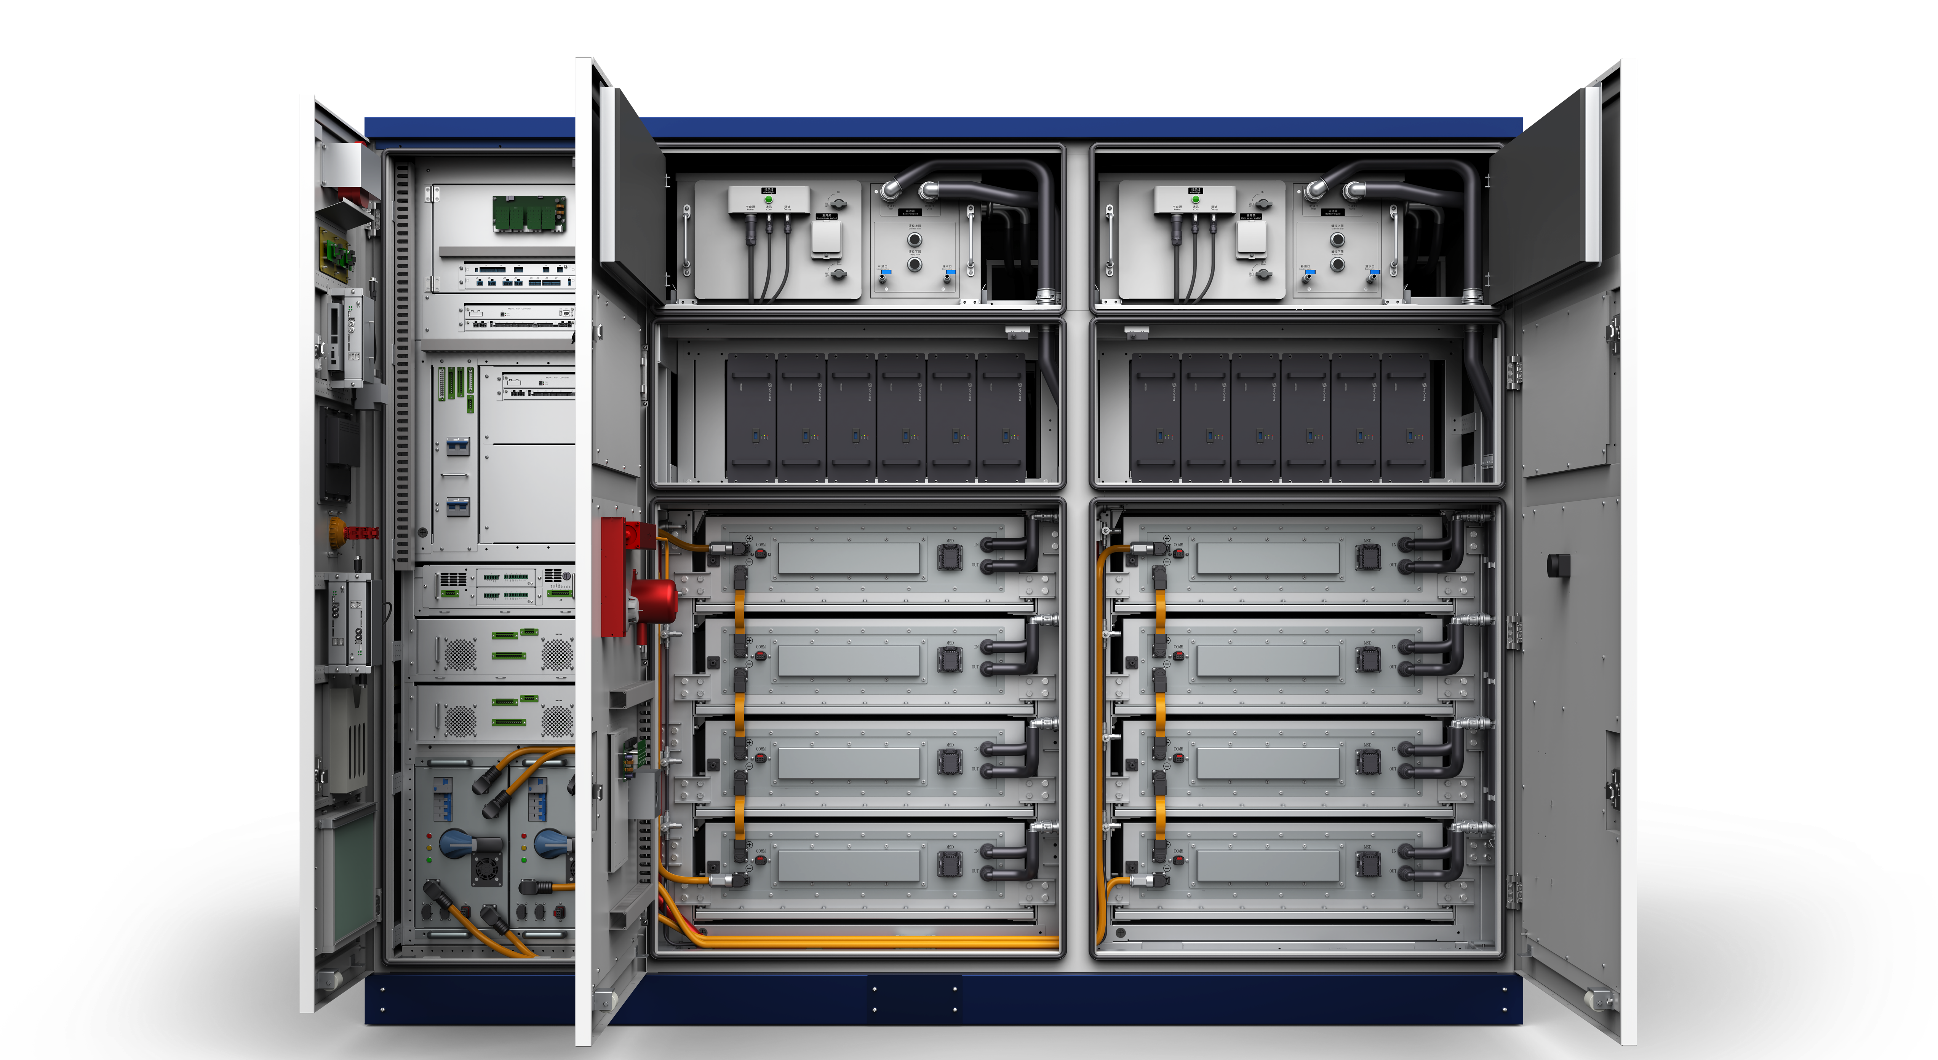 Ultra-low noise
2 option 1
Intelli
gent Power Switch
Matrix
Liquid-cooled units
MPPT DCDC
ACDC DCDC
PV
AC Grid
PV
AC Bus
Battery alarm
light and beeper Controller unit
EMS controller
MPPT
DC2DC
MPPT
DC2DC
DC/DC
AC/DC
Bidi
AC2DC
AC/DC
DC/DC
2 option 1
LCD
DC2DC
EPO
DC/DC
DC/DC DC/DC
DC/DC DC/DC
DC/DC DC/DC
Group 1
Group 2
Group 3
Group 4
DC/DC DC/DC DC/DC
Group 5 Group 6
Power switching
matrix unit box
Battery
control box
Energy & Power
Cube
#1 Charging
Dispenser
#2 Charging
Dispenser
#3 Charging
Dispenser

Battery pack

Highly integrated solution combining PV, BESS, EV charging and V2G functions

 Micro-grid enabling high-power charging  Easy relocation between sites
Backup power enabled by B2G

Power Cube IHEBS470K7D-350LL3C 470kW/350kWh
Frequency/Voltage 50Hz/60Hz, 3-phase+N+PE, 380/400Vac±10%

AC Input (On-Grid)
Max input current/power 133A/70kW
Power factor 0.8 leading ~ 0.8 lagging
Voltage DC+/- +PE, 300Vdc~740Vdc, max 900Vdc

PV Input Max input current/power 70A (with 1 PV module); 140A (with 2 PV modules)/40kW (with 1 PV module); 80kW (with 2 PV modules)
Voltage 150Vdc~1000Vdc
Max output current 6 outputs, each output max 600A
DC Output Max output power 400kW (320kW @300Vdc~1000Vdc)
Output channel Max 6 output charging channels via 3 dual-connector dispensers or 6 single-connector dispensers LCG1K0135G-M DC2DC converter, 40kW/1kV, MPPT support Max 2 * 40kWp PV input support (optional)
LCG1K0135G DC2DC converter, 40kW/1kV Max 10 * 40kW DC bus discharging power/EV charging power
Power Module/ 12 Slots LRG1K0100G AC2DC rectifier, 30kW/1kV Max 2 * 30kW DC bus charging power
LBG1K0120G Bidirectional AC2DC inverter, 35kW/1kV Max 2 * 35kW AC feedback power (optional)
Energy storage battery 2*175kWh/285Ah liquid-cooled battery packs, 547.2~696.96Vdc, 1P dis/charge, max 1.1P discharge for 10 min

Battery Pack

Performance
High voltage control box Two Infypower high voltage control boxes
BMS Infypower 2-level BMS structure: battery pack BSU + high voltage control box BMU
System efficiency 94%
Standby power 216W
Noise <60dB
Dimensions (W*D*H) 2800mm*1400mm*2200mm

Mechanical Parameters
Weight (cabinet+module) 6140kg+12*30kg=6500kg
Power switching mode Intelligent power switching matrix dynamically allocates power modules among charging connectors, maximizing overall power utilization efficiency
HMI 10" TFT touch screen, 2 RGB LED, E-STOP, battery alarm light and beeper 1 AC energy meter, optional MID-certified meter
Metering
1 or 2 DC energy meters, optional NMI Eichrecht-certified meter

Others

Charging Dispenser

DC Input
 | Input channel (DC bus) | 2 |  |  |  | 1
 | Charging cable | 2 |  |  |  | 1
 | Voltage | 150Vdc~1000Vdc
DC Output | Max output current | 2*250A | 2*375A | 500A+250A | 2*500A | 250A | 375A
 | Optional (boost current) | 2*375A | 2*500A | 700A+375A | 2*700A | 375A | 500A
 | Max output power | 2*250kW | 2*375kW | 500kW+250kW | 2*500kW | 250kW | 375kW

Fire suppression system Completely submerged aerosol fire extinguishing system, water fire interface, emergency fan Safety design Explosion-proof board configuration and fire-proof spread structure design
Environment sensor Water/temperature/humidity/door access/smoke/combustible gas sensor Protection rating NEMA 3R, IP54 for power cube, IP55 for battery cabinet, IP67 for battery pack Certification TUV CE, CB
Grid connection EN 50549, VDE-AR-N 4105, VDE-AR-N 4110
Floor-Standing Dispenser Overhead Dispenser
EXP250-FDC EXP400-FDC EXP500-LDC EXP500-LLDC EXP250-FSW EXP400-FSW
Voltage 150Vdc~1000Vdc

Dimensions (W*D*H) 500mm*260mm*1800mm 763mm*240mm*415mm
Mechanical Parameters
Weight 185kg 195kg 50kg
HMI Tempered glass protective 7" capacitive touch screen LCD for floor-standing dispenser, RGB panel LED, E-STOP,
RFID, POS (optional)
Metering DC energy meter, GB/T 29318 and JJG1149 standard, optional MID-certified meter
Monitoring interface OCPP 1.6J, support update to 2.0, PnC/smart charging/power management support, LAN 100M and LTE wireless modem support
Cable management Top-mounted two cable retractors and a light bar for floor-standing dispenser. Select one or two cable
retractors based on cable length for overhead dispenser
MBE function WEB/APP Maintenance Backend System enhances the operation and maintenance effectiveness
Others
Overcurrent/short circuit/overvoltage/undervoltage/RCD/insulation/overtemperature protection
Charging protection Reverse polarity protection
Charging connector 2*GBT/CCS/NACS or CCS+NACS/GBT/CHAdeMO or 1*GBT/CCS/NACS CCS/GBT/NACS

Charging connector capacity
CCS: 200A/250A/300A/375A/500A; NACS: 200A/300A/380A; CHAdeMO: 125A/200A;
GBT: 250A/400A/500A

Protection rating IP55/IK10 IP65
Certification TUV CE, cTUVus, RED, CB, OCA, FCC, CTEP, Energy Star
Noise 0 55dB 0

Operating Environment

Operating temperature
Transportation/Storage
temperature Relative humidity Altitude
Atmospheric pressure
Cabinet cooling
-20°C~+70°C, full power output up to 50°C, power derating 5%/°C above 50°C
-30°C~+60°C
≤95%RH, non-condensing 2000m
80kPa~110kPa
Liquid cooling
*The product is continuously evolving. Please refer to the latest datasheet for specifications.

G3 Floor-Standing Charging Dispenser

200A/250A/300A/375A/380A/500A/600A Charging Connector

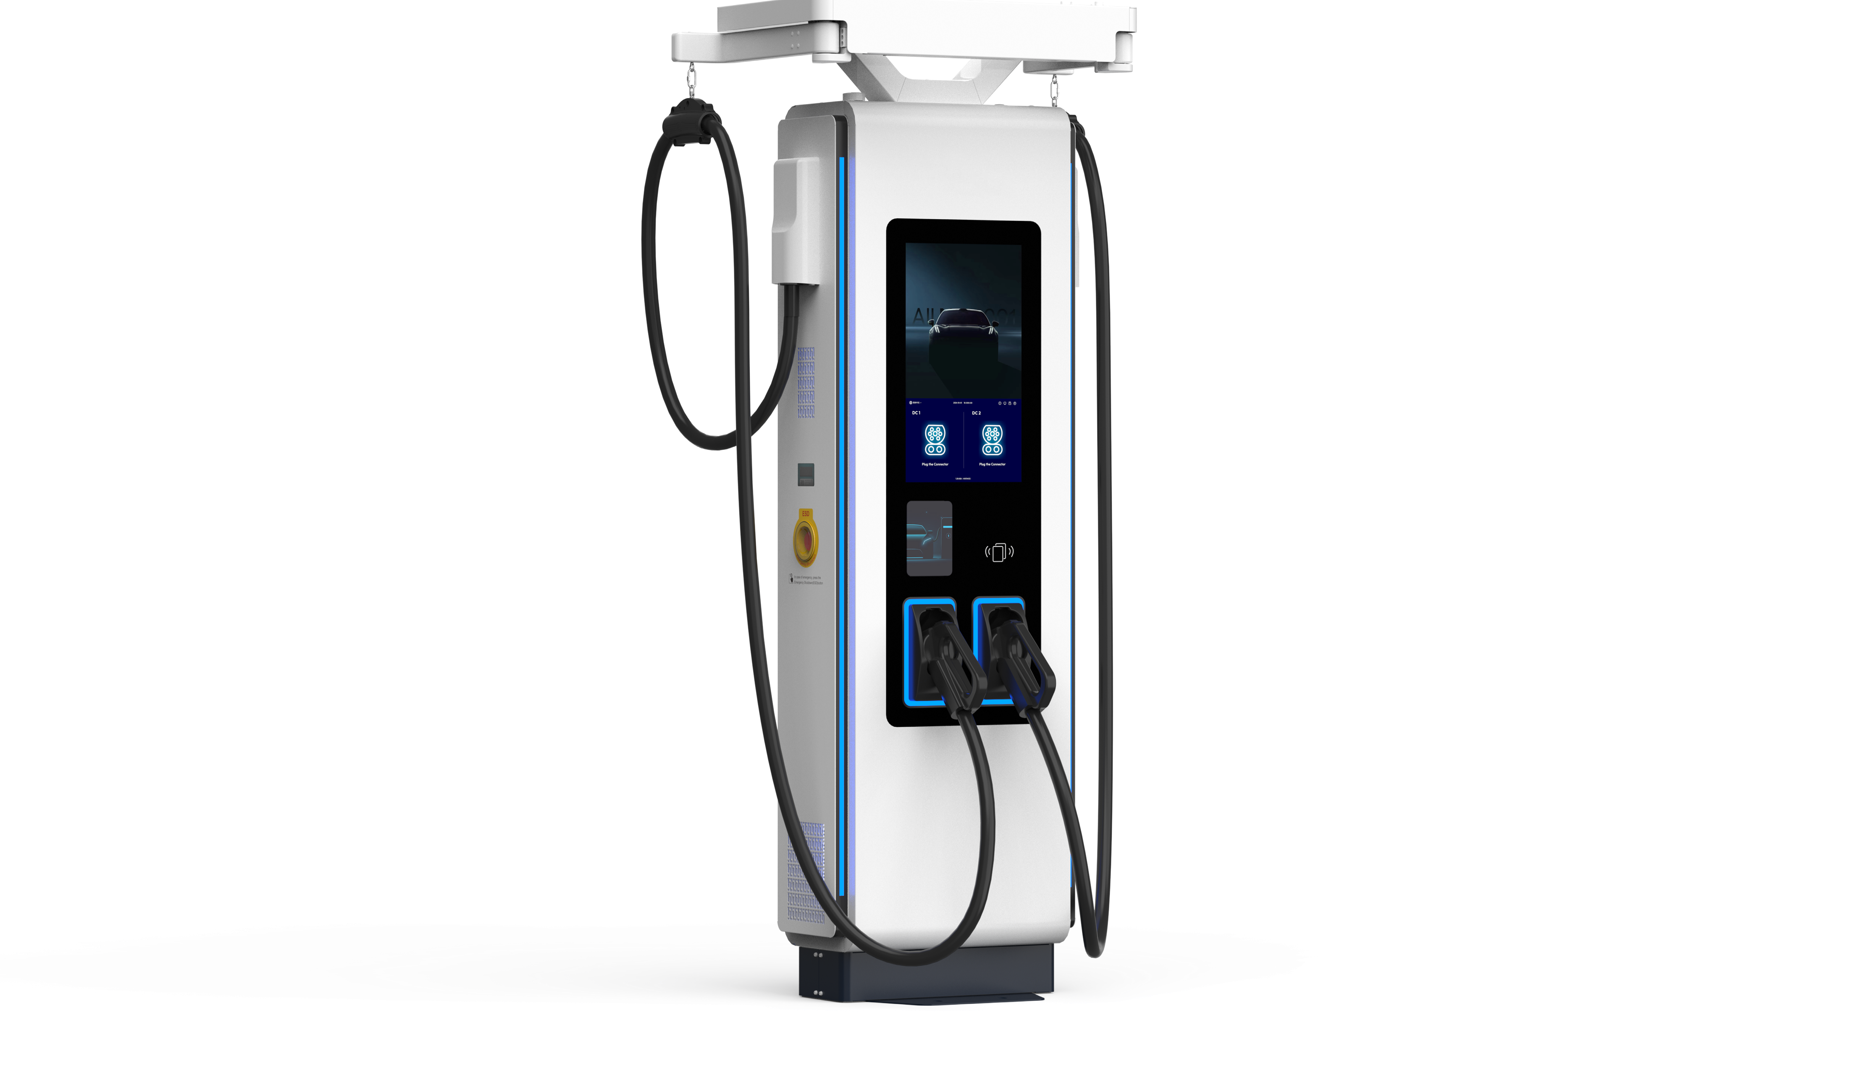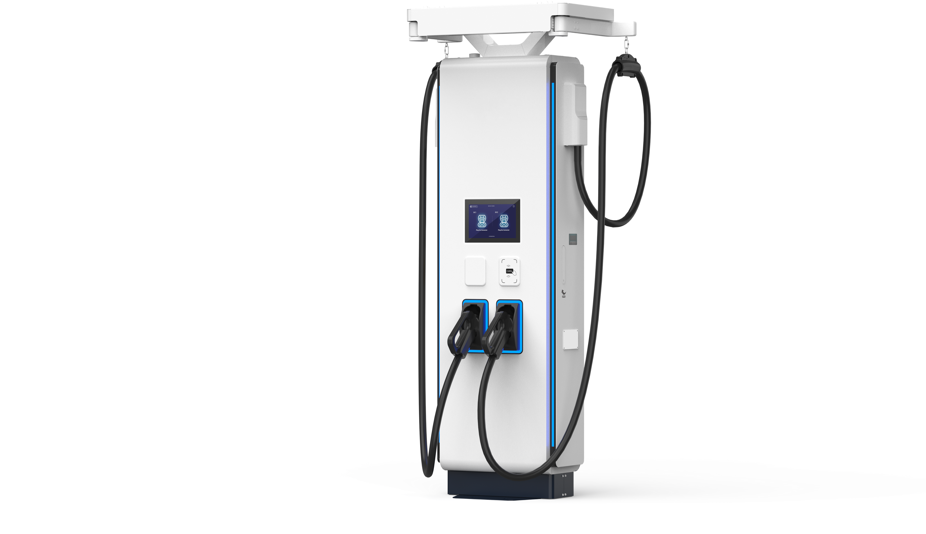

Introduction

The G3 floor-standing charging dispenser is specifically designed for EV charging operators, offering flexible split type system configurations and support for multiple charging points. It is compatible with CCS1/CCS2/NACS/GBT standards and can be configured with air-cooled charging connectors rated up to 200A (CCS1, CCS2, NACS), 250A (CCS2, GBT), 300A (CCS1, CCS2, NACS), 375A (CCS2), and 380A (NACS), as well as liquid-cooled charging connectors rated up to 500A (CCS2, GBT) and 600A (CCS1, NACS, GBT). The corresponding maximum output power for these configurations is 200kW, 250kW, 300kW, 375kW, 380kW, 500kW, and 600kW, respectively.

Main Features

IP55 (NEMA 3S)/IK10 protection rating, full- power charging from -30°C to +50°C
Optional 600A liquid-cooled charging connector
with Any Cooling™ technology

Full safety functions: output contactor and fuse,
 ESD, leakage switch, insulation detector, and
multiple-layer software protection logic
Starts charging with a simple plug-and-charge process after authentication

LTE wireless modem/Ethernet, RFID, POS and mobile app payment options

User-friendly interface with a 10.1'' (optional
 21.5'') TFT capacitive touch screen LCD protected by tempered glass

Flexible swing-arm cable retraction management for the charging connector

Model EXP250-FFC EXP400-FFC EXP500-LL5C EXP600-LL6C

EXP800-LC

Operating
Environment
Operating temperature -30°C~+70°C, full power output up to 50°C, power derating 5%/°C above 50°C Transportation/Storage
temperature -40°C~+75°C
Relative humidity ≤95%RH, non-condensing
Altitude 2000m
Atmospheric pressure 80kPa~110kPa Cabinet cooling Air cooling
Cable cooling Natural cooling Liquid cooling Protection rating IP55 (NEMA 3S)/IK10 (IK08 for 10.1" LCD, IK09 for 21.5" LCD) Noise 0 55dB
Voltage 150Vdc~1000Vdc

DC Input Input channel 2

 | Charging cable | 2
 | Voltage | 150Vdc~1000Vdc
DC Output | Max output current | 2*250A | 2*375A | 2*500A/600A | 800A
 | Optional (boost current) | 2*375A | 2*500A | 2*700A | 1000A
 | Max output power | 2*250kW | 2*375kW | 2*500kW/600kW | 800kW
Standard
Certification
Charging standard
EMC/safety
HMI
Metering
Function and
Interface
Backend
Cable management MBE function

Charging protection
Configuration

Mechanical
Parameters
Charging connector
Charging connector capacity
Dimensions (W*D*H)
Weight
TUV CE, cTUVus, RED, CB, FCC, OCA, NMI Eichrecht
NB/T 33001, NB/T 33008, EN 61851-23/24, DIN70121, ISO15118 (optional ISO15118-20) EN 61851-21-2, EN 61000-6-2/4 Class A, EN 61851-1/23/24, UL 2202, CSA C22.2
Tempered glass protective 10.1'' (optional 21.5'') capacitive touch screen LCD, RGB panel LED, E-STOP, RFID, QR code, POS (optional)
DC energy meter, MID-certified meter, optional NMI-certified meter
OCPP 1.6J/2.0.1 (optional 2.3X), PnC/OTA/smart charging/power management support, LTE wireless modem/Ethernet
Top-mounted swing-arm for cable retraction
WEB/APP Maintenance Backend System enhances the operation and maintenance effectiveness
Overcurrent/short circuit/overvoltage/undervoltage/RCD/insulation/overtemperature
protection
Reverse polarity protection
2*CCS/NACS/GBT or CCS+NACS/GBT or 1*CCS/NACS/GBT
CCS: 200A/250A/300A/375A/500A/600A; NACS: 200A/300A/380A/600A;
GBT: 250A/500A/600A
560mm*300mm*2000mm
230kg
260kg
*The product is continuously evolving. Please refer to the latest datasheet for specifications.

EXP1500 MCS Charging Dispenser

200A/250A/300A/375A/380A/500A/600A/1500A Charging Connector

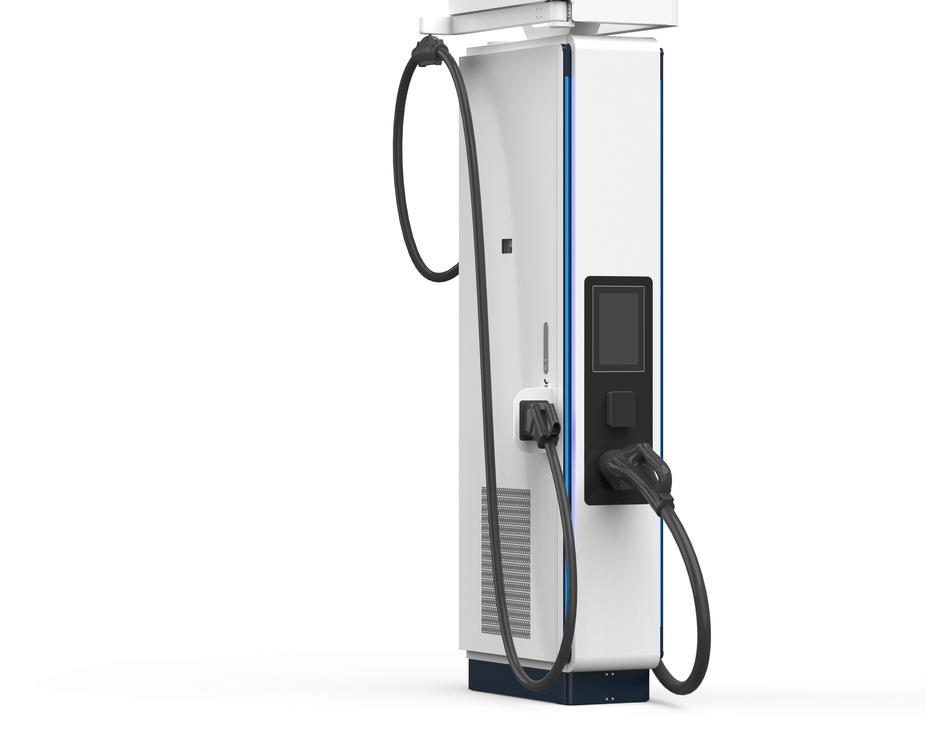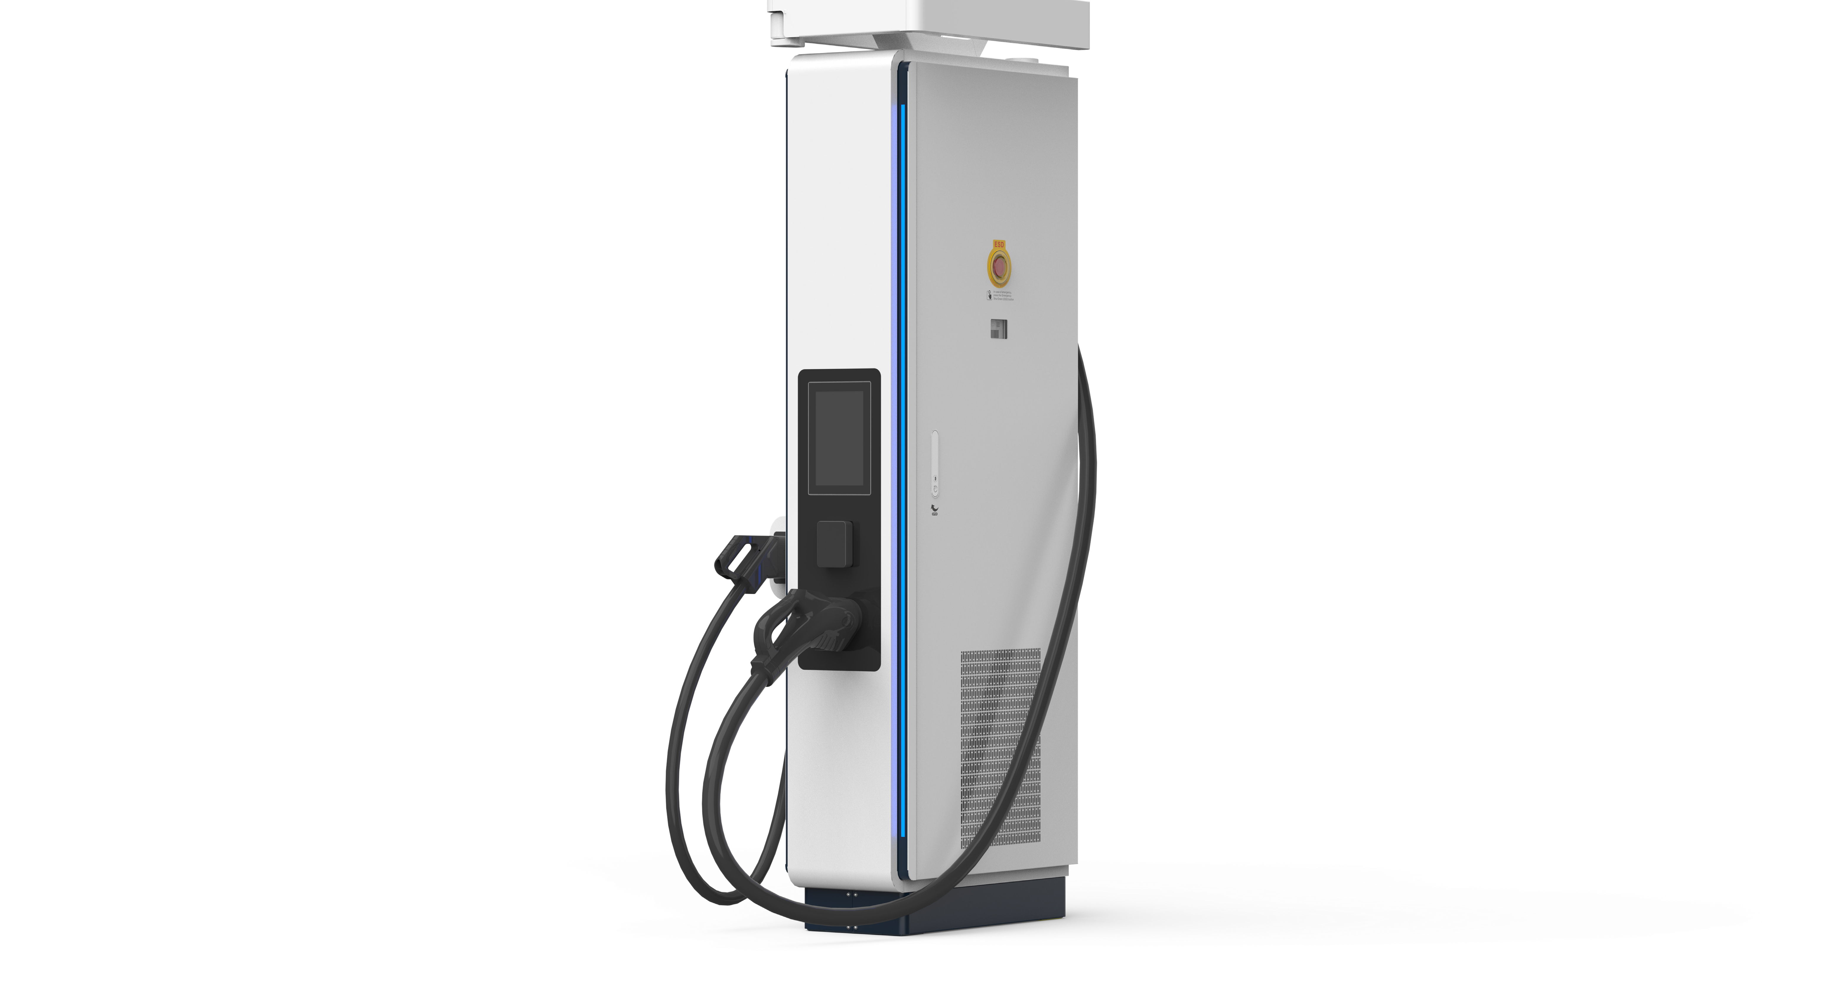

Introduction

EXP1500 Megawatt Charging System (MCS) charging dispenser is specifically designed for EV charging operators, offering flexible split type system configurations and support for multiple charging points. It is compatible with CCS1/CCS2/NACS/GBT/ MCS standards and can be configured with air-cooled charging connectors rated up to 200A (CCS1, CCS2, NACS), 250A (CCS2, GBT), 300A (CCS1, CCS2, NACS), 375A (CCS2), and 380A (NACS), as well as liquid-cooled charging connectors rated up to 500A (CCS2, GBT), 600A (CCS1, NACS, GBT) and 1500A (MCS). The corresponding maximum output power for these configurations is 200kW, 250kW, 300kW, 375kW, 380kW, 500kW, 600kW, and 1500kW, respectively.

Main Features

IP55 (NEMA 3S)/IK10 protection rating, full- power charging from -30°C to +50°C
Optional 1500A liquid-cooled charging
connectors with Any Cooling™ technology

Flexible swing-arm cable retraction management for the charging connector

Full safety functions: output contactor and fuse,
ESD, leakage switch, insulation detector, and
multiple-layer software protection logic
Starts charging with a simple plug-and-charge process after authentication

LTE wireless modem/Ethernet, QR code and POS payment options

User-friendly interface with a 10.1'' TFT capacitive touch screen LCD protected by tempered glass

Model |  | EXP1500-HLL5C (CE) EXP1500-HLL6C (UL)  -30°C~+70°C, full power output up to 50°C, power derating 5%/°C above 50°C
Operating  Environment | Operating temperature
Operating  Environment | Transportation/Storage  temperature | -40°C~+75°C
Operating  Environment | Relative humidity | ≤95%RH, non-condensing
Operating  Environment | Altitude | 2000m
Operating  Environment | Atmospheric pressure | 80kPa~110kPa
Operating  Environment | Cabinet cooling | Liquid cooling
Operating  Environment | Cable cooling | Air cooling/liquid cooling
Operating  Environment | Protection rating | IP55 (NEMA 3S)/IK10 (IK08 for 10.1" LCD)
Operating  Environment | Noise | 55dB
DC Input | Voltage | 150Vdc~1500Vdc
DC Input | Input channel | 2 or 3 (2 for MCS 1500A + optional 1 for CCS 600A)
DC Output | Charging cable | 2
DC Output | Voltage | 150Vdc~1500Vdc
DC Output | Max output current | 1500A + 600A
DC Output | Optional (boost current) | 1500A + 700A
DC Output | Max output power | 1500kW + 600kW
Standard  Function and  Interface | Certification | TUV CE, cTUVus, RED, CB, FCC, OCA, NMI Eichrecht
Standard  Function and  Interface | Charging standard | DIN70121, ISO15118 (optional ISO15118-20)
Standard  Function and  Interface | EMC/safety  HMI | EN 61851-21-2, EN 61000-6-2/4 Class A, EN 61851-1/23/24, EN 61851-23-3, UL 2202, CSA C22.2  Tempered glass protective 10.1'' capacitive touch screen LCD, RGB panel LED, E-STOP, QR  code, POS (optional)
Standard  Function and  Interface | Metering Backend | DC energy meter, MID-certified meter, optional NMI-certified meter  OCPP 1.6J/2.0.1 (optional 2.3X), PnC/OTA/smart charging/power management support, LTE wireless modem/Ethernet
Standard  Function and  Interface | Cable management | Top-mounted swing-arm for cable retraction
Standard  Function and  Interface | MBE function  Charging protection | WEB/APP Maintenance Backend System enhances the operation and maintenance effectiveness  Overcurrent/short circuit/overvoltage/undervoltage/RCD/insulation/overtemperature  protection  Reverse polarity protection
Configuration | Charging connector  Charging connector capacity | CCS+MCS/NACS+MCS/GBT+MCS/CCS+CCS, or 1*MCS  MCS: 1500A; CCS: 200A/250A/300A/375A/500A/600A; NACS: 200A/300A/380A/600A;  GBT: 250A/500A/600A
Mechanical  Parameters | Dimensions (W*D*H)  Weight | 355mm*730mm*2200mm  330kg

*The product is continuously evolving. Please refer to the latest datasheet for specifications.



IHEBV470K7D-350LL3C Liquid-Cooled All-in-One Movable Battery Buffer Charger

400kW Charging Power/2 Charging Connectors/350kWh Charger

Introduction

IHEBV470K7D-350LL3C Liquid-Cooled Movable All-in-One Battery Buffer Charger supports temporary rescue charging and off- grid power supply services. With the support of local and cloud-based EMS, it helps balance power supply and demand among the grid, battery system, EV charging and renewable energy sources. A fully liquid-cooled battery design enables 1P discharge performance, ensuring compliance with AC grid power limits while delivering high-power charging with improved energy cost efficiency and space utilization, as well as extended battery life. Its fully off-grid electrical design and reinforced structural design make it suitable for long-term transportation under vibration conditions and temporary on-site charging applications.

Main Features

Fully liquid-cooled design from power modules to battery packs and charging cables
Total electrical isolation between the grid,
battery, and EV

1P fast charging/discharging
Ultra-low noise
All-in-one design integrating BESS, EV
charging and V2G functions
Micro-grid enabling high-power charging Movable application, easy relocation
Backup power enabled by B2G

Operating temperature -20°C~+70°C, full power output up to 50°C, power derating 5%/°C above 50°C Transportation/Storage
temperature -30°C~+60°C
Relative humidity ≤95%RH, non-condensing
Operating Environment
Altitude 2000m
Atmospheric pressure 80kPa~110kPa
Cooling method Liquid cooling
Protection rating NEMA 3R, IP54 for power cube, IP55 for battery cabinet, IP67 for battery pack Frequency 45Hz~65Hz
Voltage 3-phase+(N)+PE/260Vac-530Vac
Max input power 70kW

AC Input (On-Grid)

DC Output
Max output power
(optional) 70kW
Off-grid operation Support
Grid access interface Industrial socket inlet Voltage 150Vdc~1000Vdc
Max output current 375A
Max output power 400kW
Output channel 2
Standby power 246W

Performance
Noise <60dB
AC input side 1 AC energy meter, optional MID-certified meter

Metering
DC output side 1 or 2 DC energy meters, optional NMI Eichrecht-certified meter
LCG1K0135G DC2DC converter, 40kW/1kV 10 * 40kW ES battery bus discharging/EV charging power

Power Module/12 Slots LBG1K0120G Bidirectional AC2DC inverter, 35kW/1kV 2 * 35kW AC power
Energy storage battery 2*175kWh/285Ah liquid-cooled battery packs, 547.2~696.96Vdc, 1P dis/charge, max 1.1P discharge for 10 min

Battery Pack Mechanical Parameters

Others
High voltage control box Two Infypower high voltage control boxes
BMS Infypower 2-level BMS structure: battery pack BSU + high voltage control box BMU Dimensions (W*D*H) 2800mm*1400mm*2200mm
Weight (cabinet+module) 6640kg+12*30kg=7000kg
Charging modes Auto/By Time/By Plan/By kWh/By SOC
Charging connector 2 * CCS/NACS/GBT, or CCS + NACS/GBT
Power switching mode Simultaneous charging: both charging connectors can receive 200kW
Sequential charging: both charging connectors can receive 400kW
HMI Tempered glass protective 10" capacitive touch screen LCD, RGB LED, E-STOP, battery alarm light and beeper Payment RFID, optional credit card reader installation
Monitoring interface OCPP 1.6J, support update to 2.0, PnC/smart charging/power management support, LAN 100M and LTE wireless modem support
Certification TUV CE, CB
Grid connection EN 50549, VDE-AR-N 4105, VDE-AR-N 4110

*The product is continuously evolving. Please refer to the latest datasheet for specifications.


AC Grid

AC Bus
AC/DC
LBG
BIDI AC2DC
AC/DC
LCG
DC2DC
DC/DC DC/DC DC/DC DC/DC DC/DC
DC/DC DC/DC DC/DC DC/DC
DC/DC
Energy and
Power Cube

V2G Charging Solution

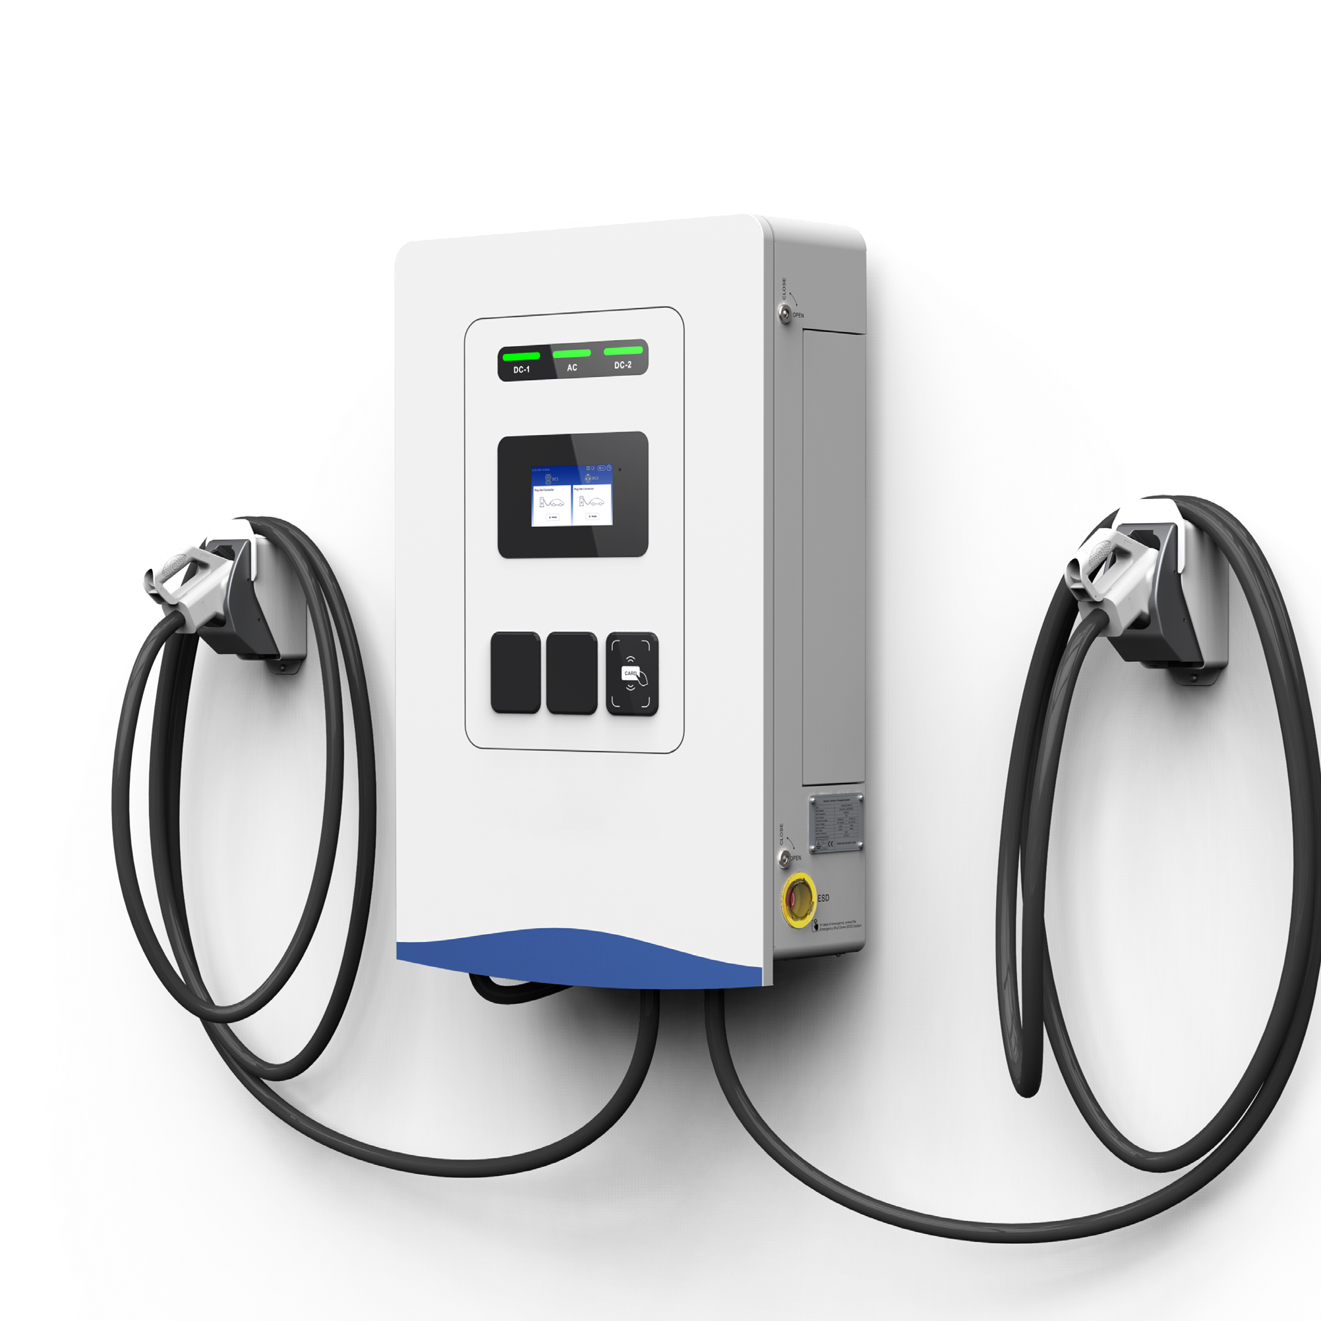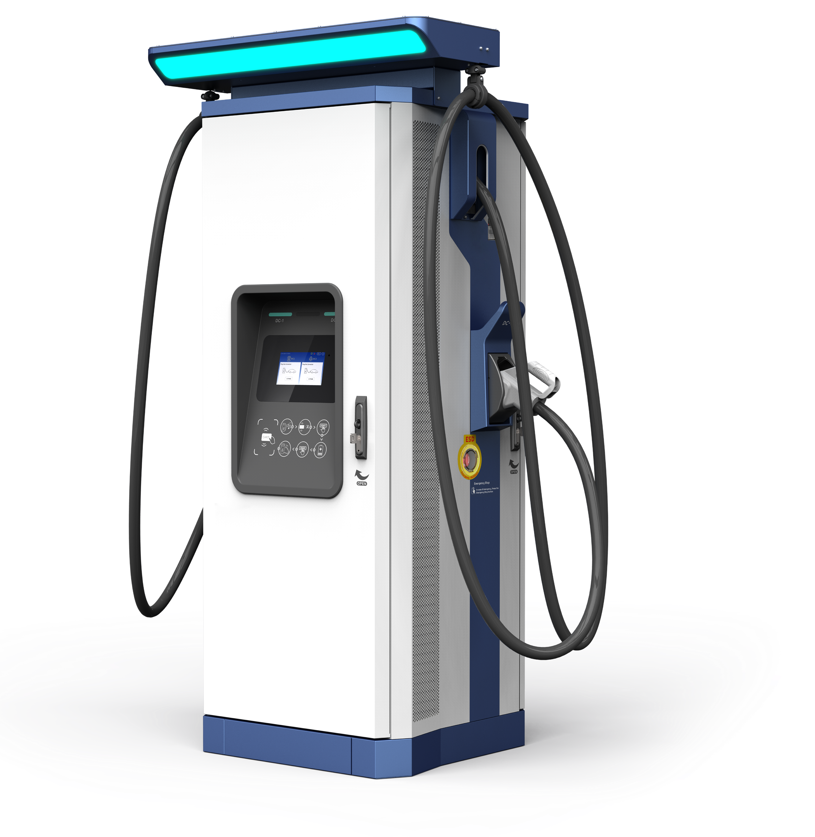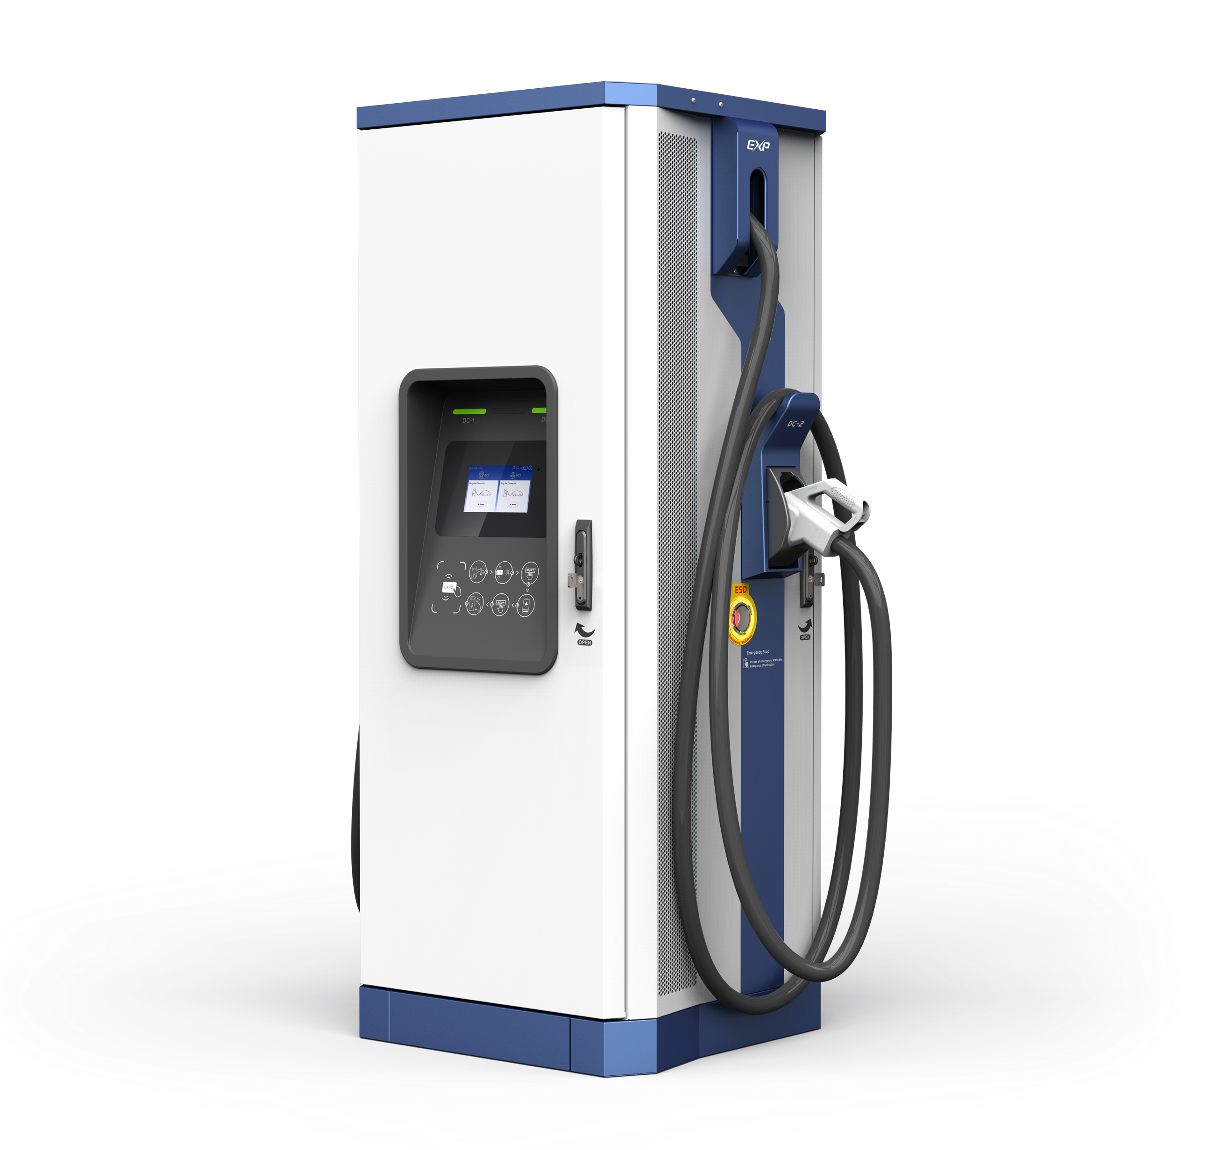22kW/44kW/66kW/132kW V2G DC Fast Charger

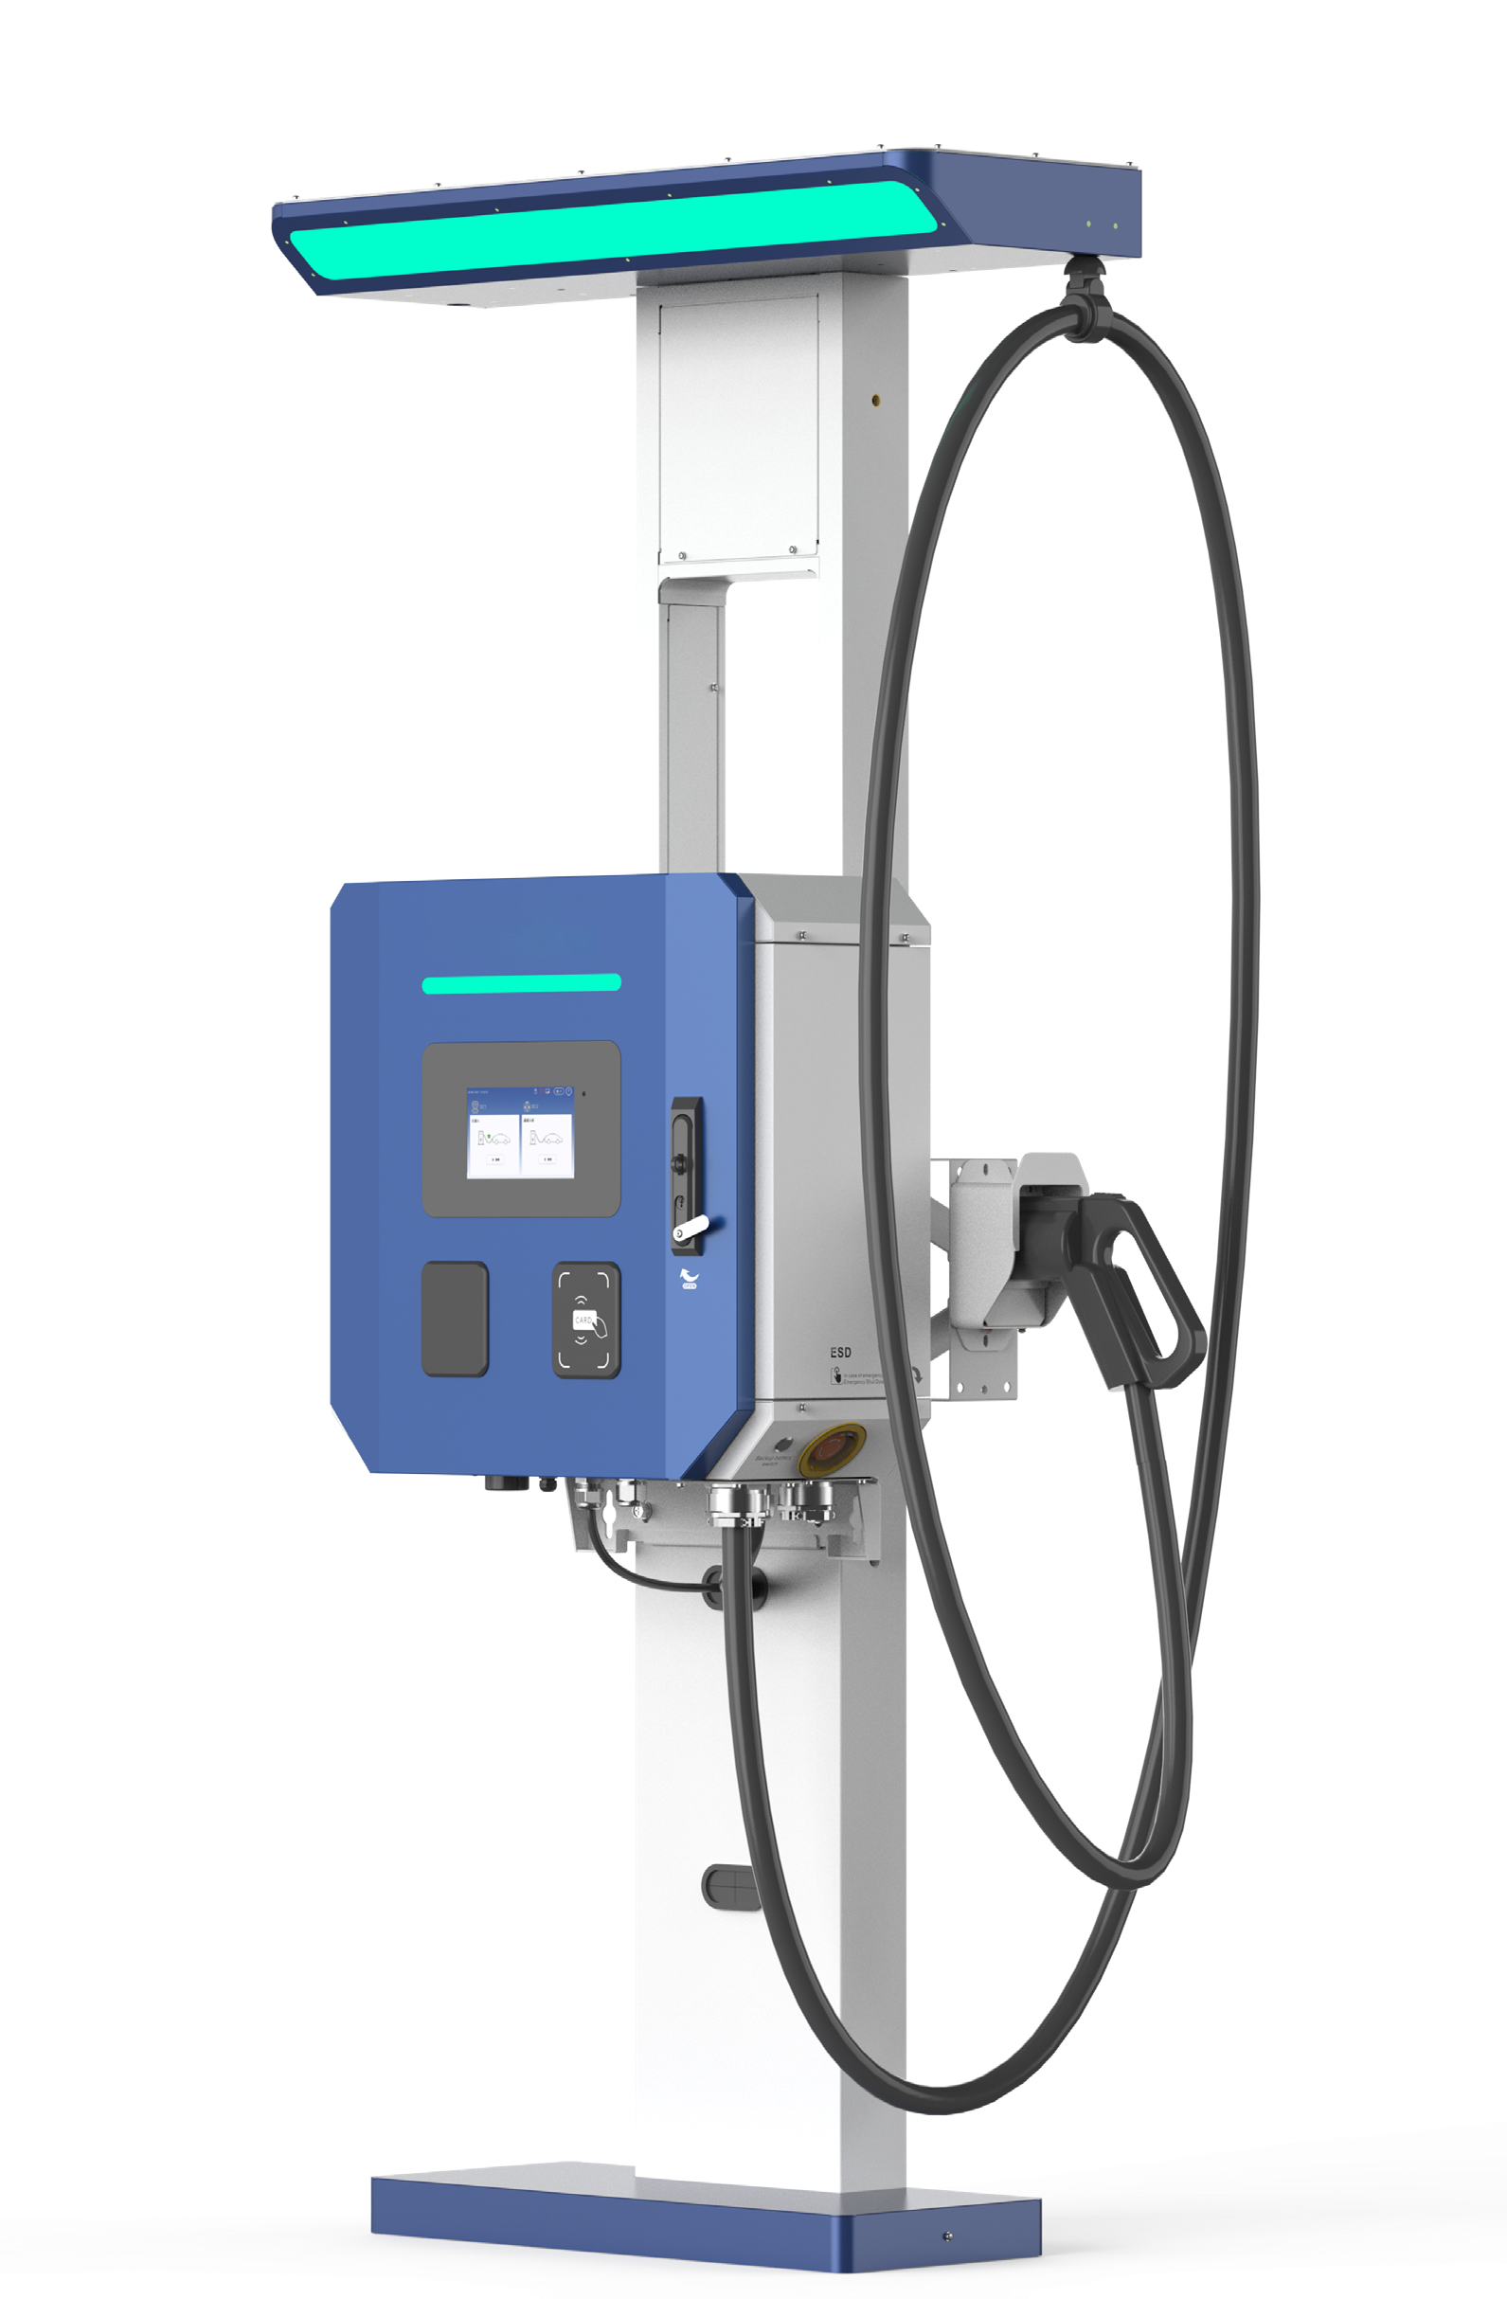

 | EXP132K3E-FD |  | EXP66K3E-FD |  | EXP44K3E-FDW |  | EXP22K3E-FSW
 | 132kW V2G Charger |  | 66kW V2G Charger |  | 44kW V2G Charger |  | 22kW V2G Charger

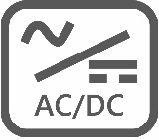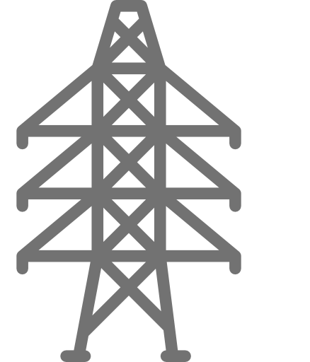22kW Bidirectional
GRID
3*22kW Bidirectional
AC2DC CONVERTER
(1~2)*22kW Bidirectional
AC2DC CONVERTER
GRID
AC2DC CONVERTER
GRID
22kW Bidirectional
AC2DC CONVERTER

22kW Bidirectional AC2DC CONVERTER
GRID
Battery Energy
Storage System
GRID
6*22kW Bidirectional
AC2DC CONVERTER

22kW Bidirectional
AC2DC CONVERTER
GRID
(3~5)*22kW Bidirectional AC2DC CONVERTER

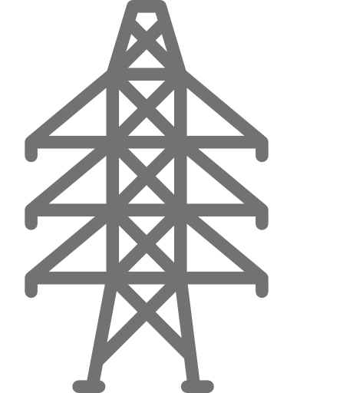(1~2)*22kW Bidirectional AC2DC CONVERTER
GRID
Battery Energy

Battery Energy Storage System

22kW Bidirectional AC2DC CONVERTER

(1~3)*22kW Bidirectional AC2DC CONVERTER

Introduction

Storage System

The V2G charger maintains a balanced power supply and demand between the grid and the EV battery by utilizing the EV battery as an energy storage device. Supported by a local or remote Energy Management System (EMS), it enables flexible access to PV energy to optimize grid peak-valley electricity utilization, enhance grid capacity, and provide reliable backup power. It functions as a core node for smart grid or microgrid integration, while also serving as a valuable supplement to user-side energy storage systems.

Main Features

Flexible system configuration, scalable capacity, bidirectional power flow, customization support
Full electrical isolation between the grid, battery
and EV

Support global V2G standards
WEB/APP Maintenance Backend System enhances
the operation and maintenance effectiveness

 Compatible with various system configurations Unified EMS strategy

Charging Strategy

Cloud EMS
OCPP 1.6J/2.0

Grid Capacity Enhancement

Backup Power Supply

Energy Management Based on the Status of Grid Side and EV Side

PV Status

EV Charging/Discharging Plan: Time/Grid Power/ES Battery Capacity/ Power Priority

Charging Implementation

ISO15118/-20

DIN70121

26 Field User
Requirement
Peak Valley Price Difference

Grid Quality Optimization

Energy Management Based on the Frame of Calendar and Time

ES Battery Dis/charging Plan: Time/SOC/Alarm/Status/ Electricity Price

V2G Charger EXP22K3E-FSW EXP44K3E-FDW EXP66K3E-FD EXP132K3E-FD
Operating temperature -30°C~+70°C, full power output below 50°C, power derating 5%/°C above 50°C
Transportation/Storage
temperature -40°C~+70°C
Cooling method Air cooling

Operating Environment
Relative humidity ≤95%RH, non-condensing
Altitude 2000m
Atmospheric pressure 80kPa~110kPa
Place of installation Indoor/Outdoor
Protection rating IP55/IK10
AC mode 45Hz~65Hz, 3-phase+(N)+PE, 260Vac~530Vac
Max AC feedback power 22kW 44kW 66kW 132kW

AC Grid Access
Power factor ≥0.99
THDi <3% (rated input)
Max charging power 22kW 44kW 66kW 132kW

EV Charging
Charging power switching Single charging connector Charging in parallel with half power or in sequence with full power between 2
charging connectors

Charging voltage 150Vdc~1000Vdc
Max V2G feedback power 22kW 44kW 66kW 132kW
EV Discharging V2G protocol standard CCS: DIN 70121, IEC 15118/-2/-20
System efficiency ≥94.5%

Performance

Metering
Standby power 39W 53.2W 60W
Noise ≤65dB ≤70dB ≤65dB
AC grid side One bidirectional AC energy meter
One bidirectional DC
Charging side
energy meter Two bidirectional DC energy meters
HMI Tempered glass protective 7" TFT touch screen LCD, RFID, RGB LED, POS (optional)
Back-end platform OCPP 1.6J, supports firmware update to 2.0x, OTA, PnC/smart charging/power management support

Function and Interface
MBE function support WEB/APP Maintenance Backend System enhances the operation and maintenance effectiveness
Charging management Pedestal with two cable retractors and the light bar
Certification TUV CE, cTUVus, RED

Reliability and Safety
EMC/Safety UL 2202, EN 62909, EN 61000-6-3/EN 61000-6-1
Class B; EN 61851-1/EN 61851-23/EN 61851-24
Grid connection VDE-AR-N 4105, EN 50549, UL 1741SB, IEEE 2030.5
UL 2202, EN 62909, EN 61000-6-3/EN 61000-6-1
Class A; EN 61851-1/EN 61851-23/EN 61851-24

BEG1K075G 22kW 1000V 1 2 3 6
Power Module Charging connector CCS1/CCS2/NACS
Dimensions (W*D*H) 640mm*270mm*610mm 705mm*240mm*1100mm 700mm*750mm*1750mm
Mechanical Parameters
 | Weight (cabinet+module) | 70kg+14kg=84kg | 90kg+2*14kg=118kg | 205kg+3*14kg=247kg 205kg+6*14kg=289kg
V2X Box |  | IAU63ATS-AW | IAU125ATS-AW
 | Frequency | 50Hz/60Hz |  | 60Hz

AC Grid Input
Rated voltage 3-phase+N+PE, 380/400Vac±10% (CE), 480Vac±10% (UL)
Current Max 63A Max 250A
3-phase+N+PE, 480Vac±10%

Frequency 50Hz/60Hz 60Hz

Backup Output

Rated voltage
3-phase+N+PE, 220/230/380/400Vac
±10% (CE), 480Vac±10% (UL)
3-phase+N+PE, 480Vac±10%

N/A

Current Max 63A Max 125A
Frequency 50Hz/60Hz 60Hz

Charger Output
Voltage 3-phase+N+PE, 380/400Vac±10% (CE), 480Vac±10% (UL)
Current Max 63A Max 125A
Dimensions (W*D*H) 360mm*560mm*220mm 508mm*220mm*850mm
3-phase+N+PE, 480Vac±10%

Mechanical Parameters
Weight 26kg 57.5kg
*The product is continuously evolving. Please refer to the latest datasheet for specifications.



Web: www.envictaenergy.com Email: contact@envictaenergy.com Tel: +1 (408) 304 7181
Add: 675 Sycamore Drive, Ste 150, Milpitas, CA 95035, United States

